Acceptability of an AI-Based Student Performance Evaluation
and Monitoring System In Non-Medical Programs

A Capstone Project Presented to the

Faculty of the

College of Information Technology and Engineering

Southwestern University - PHINMA

In Partial Fulfillment

of the Requirements for the Degree

BACHELOR OF SCIENCE IN INFORMATION TECHNOLOGY

By

DIAN XANE A. CUADRA
TEOKAN DURAN D. DEMIRCAN
EDWIN KYLE S. FLORENDO
MYCO ANGEL LOU A. VILLOMO

2026
TABLE OF CONTENTS

PAGE
TITLE PAGE . . . . . . . . . . . . . . . . . . . . . . . . . . . . . . . . . . . . . . . . . . . . . . . . . . . . . . . . . . . . . . . . . . |  | 1
TABLE OF CONTENTS . . . . . . . . . . . . . . . . . . . . . . . . . . . . . . . . . . . . . . . . . . . . . . . . . . . . . . . . |  | 2
LIST OF FIGURES . . . . . . . . . . . . . . . . . . . . . . . . . . . . . . . . . . . . . . . . . . . . . . . . . . . . . . . . . . . . . |  | 4
LIST OF TABLES . . . . . . . . . . . . . . . . . . . . . . . . . . . . . . . . . . . . . . . . . . . . . . . . . . . . . . . . . . . . . . |  | 6
CHAPTER
1 | INTRODUCTION
 | Background of the Study . . . . . . . . . . . . . . . . . . . . . . . . . . . . . . . . . . . .  Statement of the Problem . . . . . . . . . . . . . . . . . . . . . . . . . . . . . . . . . . .  Objectives of the Study . . . . . . . . . . . . . . . . . . . . . . . . . . . . . . . . . . . . . .  Scope and Limitations . . . . . . . . . . . . . . . . . . . . . . . . . . . . . . . . . . . . . .  Significance of the Study . . . . . . . . . . . . . . . . . . . . . . . . . . . . . . . . . . . | 9  12  12  13  20
 | Definition of Terms . . . . . . . . . . . . . . . . . . . . . . . . . . . . . . . . . . . . . . . . . | 22
2 | REVIEW OF RELATED LITERATURE  Review of Related Literatures Introduction. . . . . . . . . . . . . . . . . .  Challenges in Student Performance Monitoring and Academic Data Management . . . . . . . . . . . . . . . . . . . . . . . . . . . . . . . . . . . . . . . . . .  Design Principles and AI-Integrated Features in Academic Monitoring Systems . . . . . . . . . . . . . . . . . . . . . . . . . . . . . . . . . . . . . .. . .  Effectiveness of AI-Integrated Systems in Enhancing Academic Decision-Making and Data Security . . . . . . . . . . . . . . . . . . . . . . . . .  Summary of the RRLs . . . . . . . . . . . . . . . . . . . . . . . . . . . . . . . . . . . . . . | 25  26  27  28  29
3 | METHODOLOGY  Systems Architecture and Methodology Description . . . . . . . . .  Research Framework and Design . . . . . . . . . . . . . . . . . . . . . . . . . . .  Sampling and Techniques . . . . . . . . . . . . . . . . . . . . . . . . . . . . . . . . . . .  Data Gathering Tools, Techniques, and Timeline. . . . . . . . . . . . .  Software Development Methodology . . . . . . . . . . . . . . . . . . . . . . . .  Data Analysis Tools and Techniques . . . . . . . . . . . . . . . . . . . . . . . . . | 31  31  33  36  44  50
4 | RESULTS AND DISCUSSION  Response Rate . . . . . . . . . . . . . . . . . . . . . . . . . . . . . . . . . . . . . . . . . . . . . .  Demographics . . . . . . . . . . . . . . . . . . . . . . . . . . . . . . . . . . . . . . . . . . . . . .  Processes Involved in Student Performance Evaluation and  Monitoring Among SWUNEXT Faculty and Academic  Administrators. . . . . . . . . . . . . . . . . . . . . . . . . . . . . . . . . . . . . . . . . . . . . .  Challenges in Student Performance Evaluation and Monitoring  Among SWUNEXT Faculty and Academic Administrators. . . . .  Conceptual Framework . . . . . . . . . . . . . . . . . . . . . . . . . . . . . . . . . . . . .  Wireframes . . . . . . . . . . . . . . . . . . . . . . . . . . . . . . . . . . . . . . . . . . . . . . . . .  Mockups. . . . . . . . . . . . . . . . . . . . . . . . . . . . . . . . . . . . . . . . . . . . . . . . . . . . . | 54  56  58  65  69  76  78
 | REFERENCES | 90

LIST OF FIGURES

Figure No. | Figure Title | Page
1 | Sample Size Calculation | 35
2 | Agile Methodology | 45
3 | Kanban Framework | 46
4 | Percentage Formula | 51
5 | Weighted Mean Formula | 52
6 | Standard Deviation Formula | 52
7 | Maximum Sample Standard Deviation Formula | 53
8 | PowerBI | 53
9 | Distribution of Faculty Respondents by College / Department | 56
10 | Distribution of Academic Administrator Respondents by College / Department | 57
11 | Distribution of Academic Administrator Respondents by Position | 57
12 | Current Student Performance Evaluation and Monitoring  Process Flow for Academic Administrators within SWUNEXT | 58
13 | Conceptual Framework of the System Using the Input-Process-Output Model | 70
14 | Context Flow Diagram | 70
15 | Use Case Diagram | 73
16 | Data Flow Diagram | 75

LIST OF TABLES

Table No. | Table Title | Page
1 | Population Size of Respondents | 34
2 | Sample Size of Respondents | 36
3 | Capstone Manuscript Timeline | 43
4 | Estimated Project Costs | 44
5 | Software Development Tools and Platforms | 50
6 | Response Rate According to Respondent Roles | 55
7 | Response Rate According to College / Department | 55
8 | Frequency of Each Procedure in Student Performance Evaluation and Monitoring for Academic Administrators within SWUNEXT | 60
9 | Current Student Performance Evaluation and Monitoring Process Flow for Faculty Members within SWUNEXT | 62
10 | Frequency of Each Procedure in the Student Performance Evaluation and Monitoring Process for Faculty Members within SWUNEXT | 64
11 | Challenges in Student Performance Evaluation and Monitoring  Among Academic Administrators within SWUNEXT | 66
12 | Challenges in Student Performance Evaluation and  Monitoring Among Faculty Members within SWUNEXT | 68

CHAPTER 1

INTRODUCTION
Higher Education Institutions (HEIs) increasingly use digital platforms to support teaching, assessment, and student record management. However, the information needed to monitor a student throughout a semester may still be distributed across several sources. Assessment results may come from online activities, quizzes, examinations, written works, and other course requirements, while attendance and participation may be recorded separately. This fragmentation makes continuous monitoring more difficult even when individual digital tools are already available.
Within the workflow considered by this study, faculty may handle both digital and physical assessment activities. Digital activities may be administered through tools such as Google Classroom or Google Forms, while written quizzes, written works, examinations, participation, and class attendance may be recorded manually or in separate files. Official grade submission remains a separate institutional process. Consequently, faculty may need to consolidate records before they can determine a student’s current standing and identify students who require attention.
Within SWUNEXT, a cluster of colleges and schools offering non-health allied programs at Southwestern University-PHINMA, the study identified similar concerns in student performance monitoring. Faculty and academic administrators reported difficulties in consolidating records, managing performance data efficiently, retrieving useful analytical information, comparing performance across classes, and identifying students who may be at risk.
To address these concerns, this study proposes an AI-Based Student Performance Evaluation and Monitoring System that serves as a centralized decision-support workspace for faculty and academic administrators. The system organizes assessment scores, attendance, participation, and other authorized academic indicators, calculates current academic standing using configurable evaluation criteria, and applies artificial intelligence to assist in predicting performance trends and identifying students who may be academically at risk.
The proposed system is intended to assist, rather than replace, faculty judgment and existing institutional systems. Its primary purpose is to make student performance easier to organize, track, interpret, and act upon before final academic decisions are made. The study therefore evaluates the acceptability of the system as a monitoring and early-warning tool in terms of efficiency, accuracy, relevance of information retrieval, and data security.

Background of the Study
Academic administrators and teaching faculty members are responsible for monitoring and evaluating student learning in order to maintain educational quality. Student performance is commonly represented by several academic indicators, including examination results, quizzes, assignments, attendance, participation, and other course-specific requirements. Although each indicator can be recorded independently, effective monitoring requires these records to be organized in a way that allows educators to view a student’s overall progress throughout the semester.
In practice, performance records may originate from different environments. Some assessments are completed and graded through digital learning platforms, while other activities are administered physically and recorded manually. Attendance may be taken through class roll call, and faculty may maintain additional spreadsheets or class records for grade computation. When these records are maintained separately, faculty must repeatedly consolidate information before interpreting student progress, increasing the time required for monitoring and creating opportunities for inconsistent or incomplete records.
Within SWUNEXT, the survey findings show that data consolidation, time-consuming record management, limited analytical insights, progress monitoring, and the identification of at-risk students are important concerns for faculty members. Academic administrators likewise reported limited integration among existing tools and difficulty comparing performance across courses, sections, year levels, and degree programs. These findings indicate that the principal system need is not to replace existing teaching or institutional platforms, but to provide a centralized layer for performance monitoring and decision support.
Artificial intelligence provides an additional capability for this monitoring process by analyzing combinations and changes in academic indicators that may be difficult to review manually across many students. In the proposed system, AI is focused on performance prediction and at-risk identification. Its outputs are presented as decision-support information for faculty review and are not treated as final grades, automatic academic decisions, or substitutes for institutional policy.
Accordingly, the study proposes a centralized AI-Based Student Performance Evaluation and Monitoring System in which faculty can encode or import authorized performance records, maintain configurable evaluation criteria, view calculated current standing, monitor attendance and assessment trends, and review AI-assisted risk predictions. Academic administrators are provided with aggregated monitoring views for authorized classes or programs. The system is designed to complement existing academic processes while keeping official grade submission and authoritative student records outside the proposed system’s decision authority.

Statement of the Problem
This study seeks to assess the acceptability of an AI-Based Student Performance Evaluation and Monitoring System that assists SWUNEXT faculty and academic administrators in consolidating student performance records, monitoring academic progress, and identifying students who may be at risk. Specifically, this study seeks to answer the following research questions:
- What are the existing processes involved in each department of SWUNEXT when assessing and monitoring student performance?
- What are the challenges encountered by the faculty of each department of SWUNEXT when assessing students and monitoring their performance?
- What system features, AI-assisted analytical capabilities, and design frameworks can be integrated into a Student Performance Evaluation and Monitoring System to address the identified challenges in organizing records, monitoring progress, and identifying at-risk students?
- What is the level of acceptability of the proposed AI based student performance evaluation and monitoring system in terms of:
- Efficiency
- Accuracy
- Relevance of Information Retrieval
- Data Security

Objectives of the Study
This study aims to develop and evaluate an AI-Based Student Performance Evaluation and Monitoring System that centralizes student performance monitoring and assists educators in identifying students who may require academic attention. The system is designed to improve the efficiency, accuracy, relevance, and security of performance monitoring while preserving faculty judgment and existing institutional grading processes. Specifically, this study aims to:
- Identify and present a flowchart of the existing processes involved in each department of SWUNEXT when assessing and monitoring student performance.
- Identify the challenges encountered by the faculty of SWUNEXT when assessing students and monitoring their performance.
- Design and develop an AI-Based Student Performance Evaluation and Monitoring System that consolidates authorized academic indicators, supports configurable grade computation and attendance monitoring, presents analytical dashboards, and applies AI-assisted performance prediction to help identify students who may be at risk.
- Determine the level of acceptability of the proposed system in terms of:
- Efficiency
- Accuracy
- Relevance of Information Retrieval
- Data Security

Scope and Limitations
This study focuses on the design, development, and evaluation of an AI-Based Student Performance Evaluation and Monitoring System for the SWUNEXT cluster of colleges and schools at Southwestern University-PHINMA, namely the Business School (B-School), the College of Engineering (CoE), the College of Information Technology (CIT), and the School of Design and Communication (SD+C). The proposed system is primarily a teacher-assistance and academic monitoring tool that centralizes performance records and provides analytical and AI-assisted indicators for identifying students who may require attention.
The scope covers the major stages of the software development lifecycle, including requirements analysis, system architecture design, development, testing, and user evaluation. The system processes authorized academic indicators such as assessment scores, attendance, participation, and course-specific evaluation components. These records may be encoded manually or imported from supported files and, where institutional authorization and technical access are available, from approved external learning platforms.
The respondents of the study include faculty members and academic administrators, such as deans, assistant deans, program directors, program chairs, and program heads, within the colleges and schools affiliated with SWUNEXT. Faculty members are the primary operational users of the proposed system, while academic administrators use authorized aggregated views for monitoring and oversight. Technical configuration is performed by a System Admin role.
The proposed system does not replace the university’s Student Information System (SIS), official grade submission procedures, institutional grading policies, or the professional judgment of educators. Values calculated by the proposed system represent current or provisional academic standing for monitoring purposes. Direct synchronization with external systems, including Google Classroom or SWU SIS, is dependent on institutional authorization, API availability, compatibility, and access permissions and is therefore not required for the minimum viable implementation.
Scope of the Study
- Respondents: The participants of this study include teaching faculty members and academic administrators of colleges and schools affiliated with the SWUNEXT cluster who are willing and eligible to participate in the evaluation of the proposed system. Respondents are selected using stratified random sampling according to their roles.
- Locale: The study will be conducted within the colleges and schools affiliated with the SWUNEXT cluster of colleges and schools at Southwestern University PHINMA, namely the Business School (B-School), the College of Engineering (CoE), the College of Information Technology (CIT), and the School of Design and Communication (SD+C).
- Variables: The study measures the level of acceptability of the proposed system based on the following indicators:
  - Efficiency - the system’s ability to simplify and increase the speed of student performance monitoring tasks;
  - Accuracy - the correctness and reliability of the student performance data stored within the proposed system;
  - Relevance of Information Retrieval - the usefulness and clarity of the insights provided by the system in relation to student performance monitoring; and
  - Data Security - the protection of sensitive personal and academic data within the system.
- Methodology: The study follows a developmental research approach involving the design, development, and evaluation of the proposed system. Data are collected through surveys, secondary research, and system testing to assess the acceptability of the AI-assisted monitoring system in terms of efficiency, accuracy, relevance of information retrieval, and data security.
Scope of the System
The proposed system is designed as a centralized student performance monitoring and early-warning platform for authorized SWUNEXT faculty and academic administrators. It organizes performance information from different course activities and applies AI as a focused decision-support component for performance prediction and at-risk identification. The system includes the following core functionalities:
- Performance Data Consolidation and Input: Modules that allow faculty to create class records and student rosters and to encode or import assessment scores, attendance, participation, and other course-specific performance indicators. The minimum viable system supports manual and file-based input so that it remains usable even when direct external-system integration is unavailable.
- AI-Assisted Performance Prediction and At-Risk Identification: A machine-learning component analyzes available academic indicators to estimate student performance trends and classify or prioritize students who may be at risk. The generated prediction is advisory and must be reviewed by faculty before any intervention or academic decision is made.
- Customizable Evaluation Criteria and Grade Computation: Features that allow authorized academic administrators to maintain approved evaluation templates or guidelines and allow faculty to apply appropriate course-level weighting and calculation rules. The system calculates a student’s current or provisional academic standing for monitoring purposes and does not determine the official SIS grade.
- Interactive Analytics Dashboard: Dashboards present class summaries, student performance trends, grade distributions, attendance indicators, at-risk lists, and other analytical information. Dashboard values update when underlying records are added or changed; the requirement does not imply continuous streaming or autonomous decision-making.
- Security and Access Control: The system applies user authentication, Role-Based Access Control (RBAC), audit logging, and appropriate data-protection mechanisms to restrict access according to the responsibilities of System Admin, Academic Admin, and Faculty users and to protect sensitive academic information.
- Faculty-Reviewed Feedback and Reporting: The system can generate or assist in drafting performance summaries and feedback based on recorded indicators and AI outputs. Faculty members review and approve any feedback before it is communicated to students. The system also supports searchable reports and export of authorized monitoring data.
Limitations of the Study and System
This study is limited to the design, development, and evaluation of the proposed AI-Based Student Performance Evaluation and Monitoring System within selected SWUNEXT colleges and schools. The findings reflect the institutional context, policies, technological environment, and respondents included in the study and may not be directly generalizable to other institutions.
The accuracy and usefulness of the system’s AI-assisted predictions depend on the availability, completeness, consistency, and representativeness of the data used for model development and testing. Access to actual institutional student records may be restricted by privacy, authorization, and administrative requirements. When sufficient authorized institutional data are unavailable, the AI component may be demonstrated using controlled, de-identified, or synthetic test data and should be treated as a prototype that requires further institutional validation before production use.
The system is intended solely as a decision-support and monitoring platform. It does not replace institutional grading policies, official student records, final grade submission, or the professional judgment of faculty and academic administrators. External integration is treated as optional and conditional on institutional approval and technical access.
Limitation of the Study
- Generalizability: The findings are limited to respondents within the SWUNEXT cluster. Differences in grading policies, course structures, data availability, student populations, and technological resources may limit application of the findings to other academic units or institutions.
- Timeframe: The study is conducted within a limited academic period and therefore does not evaluate long-term model drift, long-term effects on student outcomes, sustained user adoption, or extended maintenance across multiple academic years.
- User Proficiency: Evaluation of the proposed system may be affected by differences in the digital literacy, familiarity with academic record tools, and adaptability of participating faculty members and academic administrators.
Limitation of the System
- Hardware and Connectivity Dependency: The proposed system relies on existing user devices and available network or Internet connectivity. The project does not include the procurement or installation of dedicated servers, computers, or networking equipment, and full offline synchronization is outside the minimum viable implementation.
- Maintenance: The project covers design, development, testing, initial deployment, and user orientation. Long-term technical maintenance, continuous updates, model retraining, and extended institutional IT support beyond the initial implementation are outside the scope of the study.
- External Integration and SIS Boundary: The system does not replace or directly control SWU SIS. Official grades continue to be handled through existing institutional procedures. Integration with Google Classroom or other learning platforms may be explored only where authorized access and compatible APIs are available; otherwise, manual encoding and file-based import serve as the supported data-entry methods.
- AI Data Availability and Model Validity: Predictive performance depends on the quality and suitability of the training and evaluation data. The study does not assume unrestricted access to historical institutional student records. AI outputs produced from controlled or non-production datasets are for prototype evaluation and must not be interpreted as institutionally validated predictions for actual students without further authorized testing.
- Decision Authority: The system assists educators by organizing records, calculating monitoring indicators, and presenting AI-assisted risk predictions. It does not automatically determine official grades, impose interventions, or make academic decisions. Faculty and authorized academic administrators retain responsibility for interpretation and action.

Significance of the Study
This study focuses on the acceptability of an AI-Based Student Performance Evaluation and Monitoring System designed to assist academic monitoring and decision-making within SWUNEXT. By concentrating the AI component on early identification and prioritization of students who may be at risk while centralizing the supporting records, the study is expected to benefit the following stakeholders:
SWUNEXT Academic Units: The study may provide evidence on the acceptability of a centralized AI-assisted monitoring approach within SWUNEXT and may inform future improvements to student performance monitoring without replacing existing institutional systems of record.
Faculty Members within the SWUNEXT Cluster: Faculty members are the primary operational users of the proposed system. They may benefit from a single workspace for organizing class records, assessment results, attendance, current standing, performance trends, and AI-assisted at-risk indicators, reducing the effort required to consolidate information before making instructional or intervention decisions.
Academic Administrators within the SWUNEXT Cluster: Deans, assistant deans, program directors, program chairs, program heads, and other authorized academic administrators may use aggregated performance summaries and trend reports to monitor classes, sections, courses, or programs and to support administrative review while leaving class-level assessment decisions with faculty.
Students within the SWUNEXT Cluster: Students may benefit indirectly from earlier and more consistent identification of performance concerns and from timely faculty-reviewed feedback. The proposed system is not intended to replace student access to official grades through existing institutional systems.
Future Researchers and the Academe: This study contributes to the growing body of research related to the integration of artificial intelligence in educational systems and secure academic data management. The findings of this research may serve as a reference for future studies exploring predictive analytics, educational technology, and the integration of information security practices within academic environments.
Researchers: The study provides the researchers with experience in the design, development, implementation, and evaluation of a learning analytics and decision-support system that combines centralized record management, information security, and AI-assisted performance prediction within a higher-education context.

Definition of Terms
To help you understand the technical terms used in this study, below are the definition of terms for your understanding.

Academic  Decision-Making | The process by which educators and administrators analyze student performance data to make informed decisions regarding grading, intervention, promotion, and instructional strategies.
Academic Indicators | Measurable components used to evaluate student performance, such as examination scores, quizzes, assignments, attendance, and class participation.
Artificial Intelligence (AI) | A branch of computer science that enables machines or systems to perform tasks that typically require human intelligence, such as analyzing data, recognizing patterns, and making predictions.
AI-Based System | A software system that incorporates artificial intelligence components to assist in analyzing data and supporting decision-making processes.
Algorithm | A step-by-step set of rules or instructions followed by a computer to solve a problem or perform a task.
Analytics Dashboard | A visual interface that displays summarized data, charts, and performance indicators to help users easily interpret information.
Confidentiality | The principle that ensures information is accessible only to authorized individuals.
Data Integrity | The assurance that data remains accurate, consistent, and unaltered unless modified by authorized users.
Data Privacy | The protection of personal and sensitive information from unauthorized access, disclosure, or misuse.
Database | An organized collection of structured data that can be easily accessed, managed, and updated electronically.
Encryption | A security process that converts readable data into coded form to prevent unauthorized access.
Faculty | An instructor or educator responsible for teaching, evaluating, and monitoring student performance.
Information Security | The protection of information and data systems against unauthorized access, use, disclosure, disruption, modification, or destruction.
Machine Learning | A subset of artificial intelligence that allows systems to learn from data and improve their performance without being explicitly programmed for every task.
Predictive Analytics | The use of statistical techniques and machine learning algorithms to analyze historical data and forecast possible future outcomes.
Role-Based Access  Control (RBAC) | A security mechanism that restricts system access based on the user’s assigned role within the organization.
System Architecture | The overall structure and design of a system, including its components and how they interact with each other.
User Authentication | The process of verifying the identity of a user before granting access to a system.
At-Risk Student | A student whose current or predicted performance indicators meet defined risk criteria and therefore requires faculty review. The designation is a monitoring aid and does not constitute an automatic academic decision.
Current Academic Standing | A provisional performance value calculated by the proposed system from the available assessment records and configured evaluation criteria. It is used for monitoring and is not the official grade recorded in the institutional Student Information System.

CHAPTER 2

REVIEW OF RELATED LITERATURE
Academic institutions continuously generate large volumes of student data from assessments, attendance, coursework, and participation. These data provide valuable insights for evaluating student performance and identifying learning gaps; however, managing and analyzing such large volumes of data has become increasingly complex for many institutions.
To address these challenges, institutions have adopted data-driven approaches such as educational data mining and learning analytics. These technologies enable the extraction of meaningful patterns from academic data, allowing educators to better understand student performance and improve decision-making processes (Du et al., 2020). In addition, artificial intelligence (AI) has emerged as a powerful tool in education, particularly through machine learning techniques that analyze historical data and generate predictive insights (Namoun & Alshanqiti, 2021).
Despite these advancements, many academic institutions still experience inefficiencies in performance monitoring due to fragmented systems, limited analytical capabilities, and inadequate data security measures. These issues highlight the need for integrated systems that can support both academic decision-making and secure data management.
This chapter reviews related literature on the challenges in student performance monitoring, the design and integration of AI-based systems in education, and the effectiveness of these systems in enhancing academic decision-making and data security.

Challenges in Student Performance Monitoring and Academic Data Management
Monitoring student performance is essential for evaluating academic progress and providing timely interventions. However, many institutions still encounter significant challenges due to fragmented systems and manual processes.
Ifenthaler and Yau (2020) explain that learning analytics can improve student monitoring by enabling institutions to analyze educational data and identify learning patterns. However, their study also highlights that many institutions struggle with integrating analytics tools into existing systems, limiting their effectiveness. These findings suggest that while learning analytics tools improve data interpretation (Ifenthaler & Yau, 2020), their effectiveness is limited without centralized systems (Du et al., 2020). Furthermore, accurate prediction depends on data quality and integration, which remains a challenge in many institutions (Namoun & Alshanqiti, 2021).
Namoun and Alshanqiti (2021) further note that accurate prediction of student performance depends on well-organized and consistent datasets. Their findings indicate that institutions often face issues such as inconsistent data collection, fragmented records, and limited analytical tools. Supporting this, Nahar et al. (2021) found that although machine learning techniques can improve prediction accuracy, their effectiveness is constrained when data is incomplete or poorly structured.
These studies indicate that institutions commonly experience challenges such as delayed access to academic data, difficulty identifying at-risk students, fragmented records, and weak access control over sensitive information. Such limitations reduce the ability of educators to make timely and informed academic decisions.
This is further supported by Ab Rahman et al. (2024), who emphasized that the effectiveness of predictive systems is highly dependent on the availability of structured and high-quality academic data.

Design Principles and AI-Integrated Features in Academic Monitoring Systems
Artificial intelligence has become an essential component in improving academic monitoring systems by enabling automated analysis and predictive capabilities. Machine learning techniques, in particular, have been widely applied to analyze academic data and support performance evaluation.
Albreiki et al. (2021) found that machine learning models can effectively predict student performance by analyzing indicators such as grades, attendance, and engagement. Similarly, Nahar et al. (2021) demonstrate that data mining techniques can identify performance trends and improve the accuracy of academic predictions.
Beyond prediction, AI technologies also contribute to improving the overall design of educational systems. Yuskovych-Zhukovska et al. (2022) highlighted that AI can support intelligent systems and adaptive learning environments, allowing educators to adjust teaching strategies based on student needs. In addition, Merino-Campos (2025) explains that AI enables personalized learning by analyzing student behavior and providing tailored feedback, while Demartini et al. (2024) show that AI systems can dynamically adjust educational content based on student progress.
These studies collectively suggest that AI should not only be used for prediction but also integrated into system design to enhance usability and effectiveness. This suggests that AI systems should extend beyond predictive functions and operate as integrated decision-support tools within academic environments. Effective academic monitoring systems should incorporate key design principles such as centralized data management, predictive analytics, real-time dashboards, and customizable evaluation criteria. In addition, security features such as encryption and role-based access control are essential to ensure safe handling of academic data.
Building on these design principles, the effectiveness of AI-integrated systems can be evaluated in terms of their acceptability within the academic environment. These principles directly inform the design of the proposed system in this study, which integrates analytical capabilities, centralized data management, and security mechanisms into a unified platform.

Effectiveness of AI-Integrated Systems in Enhancing Academic Decision-Making and Data Security
The integration of artificial intelligence into academic systems has significantly improved the ability of institutions to support data-driven decision-making. By analyzing large datasets, AI-based systems can generate insights that help educators understand student performance patterns and respond more effectively.
Ab Rahman et al. (2024) found that machine learning models can accurately predict student performance and identify students at risk of academic failure. This allows educators to implement early interventions and improve learning outcomes. Similarly, Alshabandar et al. (2022) report that AI-based systems provide more accurate predictions compared to traditional statistical methods, enhancing the reliability of academic analysis.
In addition to improving decision-making, AI-integrated systems also enhance the organization and accessibility of academic data. Centralized systems allow institutions to store, manage, and retrieve student information more efficiently, enabling real-time monitoring and analysis of performance trends. These capabilities support faster and more informed academic decisions.
However, as academic systems become more data-driven, ensuring data security becomes increasingly important. The use of digital systems requires strong security mechanisms to protect sensitive student information from unauthorized access, modification, or loss. Implementing encryption and role-based access control helps maintain the confidentiality and integrity of academic records.
Overall, these findings demonstrate that AI-integrated systems significantly improve the efficiency of performance monitoring, enhance the identification of at-risk students, improve the organization and accessibility of academic records, and strengthen the protection of academic information.

Summary of the RRLs
The reviewed literature highlights the growing importance of artificial intelligence and data analytics in improving academic monitoring systems. Studies show that educational data mining and machine learning techniques can effectively analyze academic data, identify patterns, and predict student performance.
However, the literature also reveals persistent challenges in existing systems, including delayed access to academic data, fragmented records, and limited analytical capabilities. While many studies focus on predictive models, fewer address the integration of system features and data security within a single platform.
Moreover, existing research emphasizes the importance of combining analytical capabilities with effective system design and security measures. AI-integrated systems have been shown to improve academic decision-making by providing timely insights and enabling early identification of at-risk students. At the same time, secure data management practices are necessary to protect sensitive academic information.
While existing research highlights the importance of managing educational data, few studies simultaneously address both academic decision-making support and data security within a unified system framework. This gap highlights the need for a comprehensive and integrated system that combines performance evaluation, predictive analytics, and security mechanisms to improve academic monitoring processes.

CHAPTER 3

RESEARCH AND SYSTEM DEVELOPMENT METHODOLOGY
This chapter describes the research methodology used to address the study objectives and the system development approach for the proposed AI-Based Student Performance Evaluation and Monitoring System. It covers the research framework and design, sampling, data collection procedures, software development methodology, tools and platforms, system architecture, and data-analysis techniques.

Research Framework and Design
This study employs a quantitative research approach in addressing both the conceptual and computational aspects of the student performance evaluation and monitoring processes of the colleges and schools affiliated with SWUNEXT.
For Research Question 1, the researchers opted to use a quantitative research approach with a descriptive research design. A quantitative research approach is suitable for a controlled quantifiable and statistical measurement of the processes involved in evaluating and monitoring student performance among the faculty members of the colleges and schools affiliated with SWUNEXT. Quantitative research focuses on the collection and analysis methods and techniques of numerical data, and is utilized in finding objective and systematic answers to research questions or hypotheses (Slater & Hasson, 2025). For Research Question 1, a descriptive research design is suited for identifying and characterizing the processes involved in monitoring student performance at SWUNEXT, which serves as the baseline for the development of an AI-Based Student Performance Monitoring System that enhances these processes. Descriptive research is a type of research design used to determine the characteristics of a population or phenomenon in order to obtain a factual and systematic description of its condition (Salisi & Balahadia, 2025).
For Research Question 2, the researchers use a quantitative research approach with a descriptive research design. This approach is suited for measuring and characterizing the challenges experienced by faculty members and academic administrators in student performance evaluation and monitoring. The resulting findings provide the operational basis for prioritizing the system requirements that address record consolidation, monitoring efficiency, information retrieval, and identification of at-risk students.
For Research Question 3, the researchers opted to use a qualitative secondary research approach with a systematic literature review design. According to Manu and Akotia (2021), qualitative secondary research is a “a systematic approach to the use of existing data to provide ways of understanding that may be additional to or different from the data’s original purpose”. A secondary research approach is suited for understanding the latest advances in the literature relevant to the design principles, system features, and security controls necessary in the development of an AI-Based Student Performance Evaluation and Monitoring System that addresses the identified challenges in the existing student performance evaluation and monitoring process as experienced among faculty members and academic administrators within SWUNEXT.
For Research Question 4, the researchers opted to use a quantitative research approach with a developmental research design because a quantitative research approach is suited for the controlled statistical measurement of variables in the assessment of the acceptability of the proposed AI-Based Student Performance Evaluation and Monitoring System as a solution in improving the student performance evaluation and monitoring of the colleges and schools affiliated with SWUNEXT, while a developmental research design is suited for systematically guiding the development and assessment of the acceptability of the proposed AI-Based Student Performance Evaluation and Monitoring System in terms of the existing student performance evaluation and monitoring processes of academic institutions, and thereby, in addressing the challenges encountered by faculty members of the colleges and schools affiliated with SWUNEXT in evaluating and monitoring student performance. Developmental research focuses on the systematic design, development, and evaluation of products and solutions that meet criteria for internal consistency and effectiveness (Salisi & Balahadia, 2025).

Sampling and Techniques
The researchers opted to utilize a probability sampling method using a stratified random sampling technique without replacement in selecting the respondents of the study. According to Rahman (2023), probability sampling is commonly used when ensuring a method for equal probability of selection, conducting studies that are generalizable to a wide population. Stratified random sampling is a probability sampling technique that involves the classification of a population into distinct groups, also known as strata, and the random selection of participants from each stratum to form a representative sample of the entire population (Ahmed, 2024). Stratified random sampling ensures equal representation of strata, providing comparability within or across strata. (Ahmed, 2024).
The researchers formulated the following inclusion criteria for the various data collection procedures in order to ground the applicability of the respondent samples. For the pre-development and post development surveys, the respondents:
- Must be academic administrators, including but not limited to: Deans, Assistant Deans, Program Directors / Executive Directors, Program Chairs, and Program Heads, who are currently employed or contracted with a college or school affiliated with the SWUNEXT cluster of colleges and schools at Southwestern University PHINMA at the time of data collection, who have been involved in administrative processes in relation to student performance evaluation and monitoring for at least one full semester inclusive of Second Semester, Academic Year 2025-2026, and who are willing and able to participate in the data collection; or
- Must be teaching faculty members, including but not limited to instructors, professors, or teaching assistants, regardless of full-time or part-time status, who are currently employed or contracted with a college or school affiliated with the SWUNEXT cluster of colleges and schools at Southwestern University PHINMA at the time of data collection, who have assessed and monitored student performance at the undergraduate, graduate, or post-graduate level for at least one full semester inclusive of Second Semester, Academic Year 2025-2026, and who are willing and able to participate in the data collection.

Table 1 presents the population size of each respondent group across the different respondent groups among the various colleges and schools affiliated with SWUNEXT.

College / Department | Number of Academic Administrators | Number of Teaching Faculty | Total
Business School | 4 | 23 | 27
College of Engineering | 2 | 3 | 5
College of Information Technology | 1 | 6 | 7
School of Design and Communication | 5 | 24 | 29
Total | 12 | 56 | 68
Table 1. Population Size of Respondents

The overall sample size across all respondent groups was determined using Cochran’s formula with a finite population factor to account for the finite number of respondents, then the overall sample size for each college or department was calculated using proportional allocation. Figure 1 demonstrates the sample size calculation for each respondent group using Cochran’s formula.
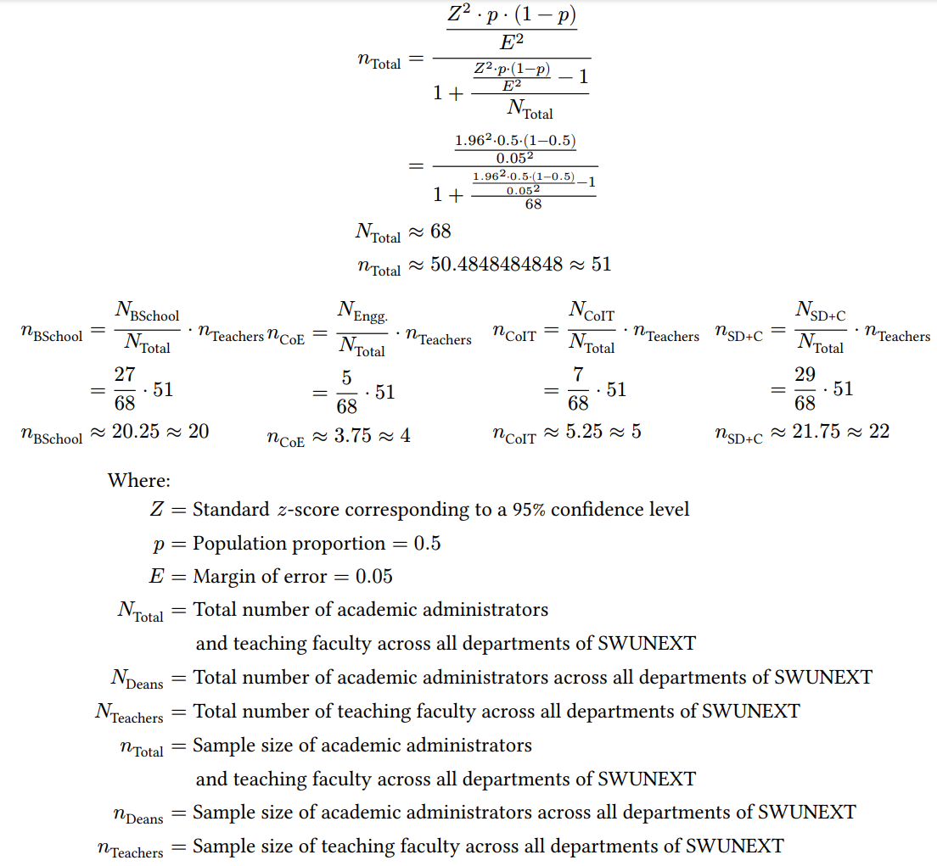
Figure 1. Sample Size Calculation
The researchers opted for a confidence level of 95% to account for values within two standard deviations from the mean and a 5% margin of error to account for errors made during the sampling process. Table 2 identifies the sample sizes across each department using Cochran’s formula, respectively.
Respondent Group | Population Size | Faculty Sample Size | Academic Administrator Sample Size | Total Sample Size
Business School | 27 | 17 | 3 | 20
College of Engineering | 5 | 2 | 2 | 4
College of Information Technology | 7 | 4 | 1 | 5
School of Design and Communication | 29 | 18 | 4 | 22
Total | 68 | 41 | 10 | 51
Table 2. Sample Size of Respondents

Data Gathering Tools and Techniques
The data gathering process is divided into pre-development and post-development phases. In the pre-development phase, quantitative data for Research Questions 1 and 2 are collected from selected faculty members and academic administrators to identify existing monitoring processes and the challenges encountered. Research Question 3 is addressed through secondary research and literature review to identify appropriate system features, AI-assisted analytical approaches, and security controls. In the post-development phase, the completed system is evaluated through a survey in relation to Research Question 4.

Procedures for Data Collection
The following sub-sections outline the techniques, procedures, and specifications of the data collection process for both the pre-development and post-development phases. The sub-sections shall cover the research instrumentation, medium and modality of data collection, subject matter of the data collected, and applicable ethical considerations.

Pre-Development Phase
The researchers shall observe the following techniques, procedures, and specifications in conducting the pre-development survey in relation to Research Question 1 and Research Question 2:
- The survey shall be conducted with the selected faculty members and academic administrators of colleges and schools affiliated with the SWUNEXT cluster, as selected via stratified random sampling, and can be conducted either via asynchronous distribution of survey questionnaires, or with the guidance of the researchers.
- A survey questionnaire shall serve as the research instrument, consisting of fifteen close-ended questions measuring the processes involved in assessing and monitoring student performance and the challenges faced by the faculty members in evaluating and monitoring their students’ performance throughout the semester, in terms of academic decision-making and data security. The survey includes topics such as:
  - Demographic Information, which includes the College / Department, and the role or position of the respondent group, and their teaching or administrative experience in student performance monitoring (as applicable). Participants may also opt to include their contact number or student number for verification purposes;
  - Current Practices in Student Performance Evaluation and Monitoring, which includes the procedures and tools used in the student performance evaluation and monitoring process; and
  - Challenges in Student Performance Evaluation and Monitoring, which includes the challenges faced by faculty members and academic administrators in assessing and monitoring student performance.
- The survey questions and responses shall conform to either a nominal level of measurement or an ordinal level of measurement using ranked choice, or a five-point Likert-type scale, with a neutral value, shall be presented in a table format, and shall be clustered in accordance with each research sub-question.
- The survey questionnaire shall be administered via Google Forms and shall contain the raw recorded responses. The responses of each participant will be exported for statistical analysis and visualization.
- In lieu of the absence of the Institutional Review Board’s evaluation of the study, the following procedures shall be observed due to ethical considerations:
  - Prior to the start of , a request letter shall be submitted to and signed by the Deans of each faculty member or academic administrator’s college or department.
  - Prior to the conduct of the survey with each participant, a Participant Information Sheet and Informed Consent Form must be read and signed by the participant, in order to obtain the consent of each participant. The selection of the analogous option in the Google Form shall serve as a sufficient proof of consent in cases where the researchers have not interacted face-to-face with the respondent.

Post-Development Phase
The researchers shall observe the following techniques, procedures, and specifications in conducting the post-development survey in relation to Research Question 4:
- The survey shall be conducted with the selected faculty members and academic administrators of colleges and schools affiliated with the SWUNEXT cluster, as selected via stratified random sampling, and can be conducted either via asynchronous distribution of survey questionnaires, or with the guidance of the researchers after the development of the proposed AI-Based Student Performance Evaluation and Monitoring System has been completed and the participants have interacted with the completed system.
- A survey questionnaire shall serve as the research instrument, consisting of fifteen close-ended questions measuring the faculty members and academic administrators’ level of acceptability of the then-completed AI-Based Student Performance Evaluation and Monitoring System in terms of efficiency, accuracy, relevance of information retrieval, and data security, and thereby addressing the identified challenges faced by faculty members and academic administrators of colleges and schools within the SWUNEXT cluster, in assessing and monitoring students’ performance.
- The survey questions and responses shall conform to either a nominal level of measurement or an ordinal level of measurement using a five-point Likert-type scale, with a neutral value, shall be presented in a table format, and shall be clustered in accordance with each research sub-question.
- The survey shall also contain a section with open-ended questions for any feedback provided by the participants.
- The survey questionnaire shall be administered via Google Forms and shall contain the raw recorded responses. The responses of each participant will be exported for statistical analysis and visualization.
- In lieu of the absence of the Institutional Review Board’s evaluation of the study, the following procedures shall be observed due to ethical considerations:
  - Prior to the start of , a request letter shall be submitted to and signed by the Deans of each faculty member or academic administrator’s college or department.
  - Prior to the conduct of the survey with each participant, a Participant Information Sheet and Informed Consent Form must be read and signed by the participant, in order to obtain the consent of each participant. The selection of the analogous option in the Google Form shall serve as a sufficient proof of consent in cases where the researchers have not interacted face-to-face with the respondent during the data collection process.

Project Timeline and Milestones
A research timeline outlines the significant milestones and activities throughout a research project, facilitating the efficient allocation of time, ensuring the project’s feasibility, organization, alignment with its intended research objectives, and its timely completion (Ali & Kamraju, 2023). The particulars of the capstone project and manuscript have undergone various changes and revisions, thus the particulars of each step of the capstone project are presented logically instead of chronologically. The overall timeline of the capstone project is separated into two timelines; Table 3 outlines the timeline of the capstone manuscript.

Phase | Particulars | Task / Objective | Target Date of Completion | Milestone Indicator
Initiation | Group Formation | Formation of group members | January 6, 2026 | Registered group code
Initiation | Letter of Intent and Acceptance of Project Proposition | Express intent of capstone project and receive acceptance of project proposition from validating officer | March 10, 2026 | Signed Letter of Intent and Acceptance of Project Proposition
Planning | Project Proposal and Title Defense | Formulate project idea and project title | February 27, 2026 | Approved capstone project proposal and project title
Planning | Chapter 1 - Introduction | Formulate background, research problem, research questions, research objectives, scope and limitations, significance of the study, and definition of terms | March 9, 2026 | Chapter 1 completed
Planning | RRL Inventory | Collect, organize, annotate, paraphrase and cite sources needed for Chapter 2 | March 20, 2026 | RRL inventory document
Planning | Chapter 2 - Review of Related Literature | Narrate current state of research, analyze related literature, summarize and synthesize themes among related literature, and Identify research gaps | March 20, 2026 | Chapter 2 completed
Planning | Chapter 3 - System Architecture and Methodology | Formulate research framework and design, research problem, data collection tools, techniques, and procedures, data analysis tools and techniques, system architecture, system development methodology, tools and platforms, system features, project timeline and cost estimates, architectural diagrams, and prototypes | March 20, 2026 | Chapter 3 completed
Execution | Pre-Development Phase 1 | Collect informed consent from participants and conduct pre-development survey in relation to RQ1 and RQ2 | March 25, 2026 | Data collected for RQ1
Execution | Data Analysis for RQ1 and RQ2 | Analyze collected data from survey in relation to RQ1 and RQ2 | March 25, 2026 | Chapter 4 partly written with results and findings for RQ1 and RQ2
Execution | Proposal Defense | Present capstone project proposal and findings in relation to RQ1 and RQ2 | March 25-31, 2026 | Proposal defense completed
Execution | Pre-Development Phase 2 | Perform systematic literature review in relation to RQ3 | April 10, 2026 | Data collected for RQ3
Execution | Data Analysis for RQ3 | Analyze and synthesize findings from the systematic literature review in relation to RQ3 | July 24, 2026 | Chapter 4 partly written with results and findings for RQ3
Execution | Post-  Development Phase | Collect informed consent from participants and conduct post-development survey in relation to RQ4 | October 16, 2026 | Data collected for RQ4
Execution | Data Analysis for RQ4 | Analyze collected data from the post-development survey in relation to RQ4 | October 30, 2026 | Data analyzed and visualized for RQ4
Execution | Chapter 4- Results and Discussion | Narrate interpretation and analysis of results for each phase in relation to RQ1-RQ4 | November 6, 2026 | Chapter 4 completed with results and findings for RQ1-RQ4 with visualizations
Execution | Chapter 5 - Conclusion and Recommendations | Synthesize conclusion and recommendations based on the results and findings in Chapter 4 | November 6, 2026 | Chapter 5 completed
Execution | Manuscript Revision | Perform final content, style, and formatting revisions | November 13, 2026 | Manuscript ready for final defense
Closure | Final Oral Defense | Present the capstone project to the panel | November 20, 2026 | Final defense completed
Table 3. Capstone Manuscript Timeline

Project Estimated Cost
Table 4 provides a detailed breakdown of all necessary material, administrative, labor, and resource subscription costs related to the manuscript writing and publication, data collection, system development and defense of the capstone project.
Item | Description | Item Cost | Quantity | Subtotal
Material and Administrative Costs
1 | Manuscript Printing Costs | ₱1.00  / page | (4 chapters x ~30 pages  + 1 chapter x ~100 pages)  x ~8 revisions = 1,760 pages | ₱1,700.00
2 | Participant Information Sheet and Informed Consent Form Printing Costs | ₱1.00  / page | (~73 respondents x 2 instruments  ~448 respondents x 1 instrument)  x 4 pages = 2,376 pages | ₱2,376.00
3 | Capstone Adviser Notary Fee | ₱500.00 | 1 | ₱500.00
4 | Capstone Advisory Fees | ₱5,000.00 | 2 | ₱10,000.00
5 | Proposal Defense Fee | ₱ 3,000.00 | 1 | ₱ 3,000.00
6 | Post-Survey Questionnaire Printing Costs | ₱1.00  / page | (~448 respondents x 8 pages)  = 3,584 pages | ₱3,584.00
7 | Final Manuscript Printing Costs | ₱ 1.00  / page | (4 chapters x ~30 pages  + 1 chapter x ~100 pages)  x ~5 copies = 880 pages | ₱880.00
8 | Bookbinding Costs | ₱ 1,000.00 / copy | 6 copies | ₱ 6,000.00
9 | Final Defense Fee | ₱ 3,000.00 | 1 | ₱ 3,000.00
Material and Administrative Cost Subtotal |  |  |  | ₱29,340.00
System Development Costs
10 | AI Subscription Costs | $ 10.00 / 1M tokens | 1M tokens | ₱ 5,921.97
11 | Supabase Subscription Costs | $25.00  / month | 6 months x 2 developers  = 12 periods | ₱ 17,757.63
Development Cost Subtotal |  |  |  | ₱23,679.60
Grand Total |  |  |  | ₱53,019.60

Table 4: Estimated Project Costs

Software Development Methodology
The researchers will employ the Agile software development methodology in developing the proposed system. Agile was selected for its incremental and iterative approach, which supports progressive implementation of the core monitoring workflow before more data-dependent functions, such as AI prediction and external integrations, are validated. This approach also allows feedback from faculty members, academic administrators, and system testing to be incorporated into subsequent development iterations (Tetteh, 2024). Figure 2 illustrates the phases of the Agile software development methodology.
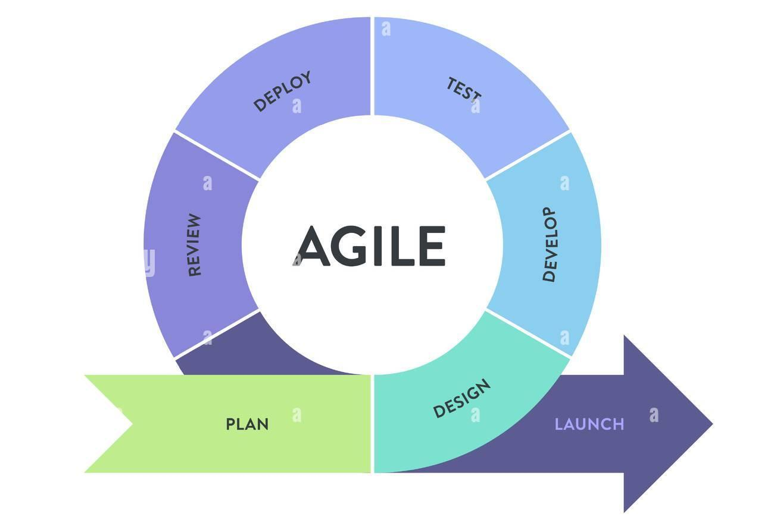
Figure 2. Agile Methodology
Kanban Framework
Kanban is a project management framework that is commonly used for the visual implementation of Agile principles in software development and other industries, and emphasizes flexibility, workflow visualization, work-in-progress minimization, optimal project resource allocation, incremental improvement, and risk mitigation (Tetteh, 2024).
In the Kanban framework, work items are visualized as cards and placed in a Kanban board, a tabular form of visualizing a project’s progress. Lanes are used to denote specific categories of work and resource allocation, depending on a work item’s status within the project, and are visualized as columns in the Kanban board. Each lane is limited by a maximum number of tasks allowed to be performed at the same time, also known as a lane’s capacity. Figure 3 illustrates the Kanban Framework via a Kanban board.
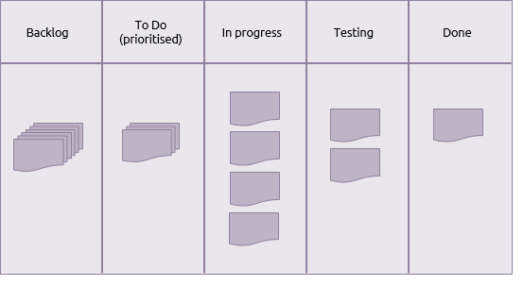
Figure 3. Kanban Framework
The following process shall be used in the development workflow of the proposed system:
- Backlog - Data gathered from research participants and other stakeholders, requirements analysis, and other phases are analyzed, converted into functional requirements, and a corresponding card is placed onto the Backlog lane, which represents the complete scope of work to be performed and indicates all the possible tasks and features to be implemented. This phase corresponds to the Plan and Design phases of the Agile software development methodology.
- To Do - A number of cards shall be moved from the Backlog lane onto the To Do lane, which indicates the work items that have been prioritized and are ready to be performed. Each card in the To Do lane must be categorized by their importance, the start and completion dates of each work item must be scheduled, and the responsible person and resources must be noted in each card. This phase corresponds to the Plan phase of the Agile software development methodology.
- In Progress - Once the development team has ample resources to complete a new task, a task shall be moved from the To Do lane onto the In Progress lane, which indicates the tasks that are currently being performed. The status of each work item is noted as the implementation progresses. This phase corresponds to the Develop phase of the Agile software development methodology.
- Blocked - If the implementation of an in-progress work item cannot proceed due to an issue, the corresponding card is placed onto the Blocked lane while the analysis or resolution of the issue takes place. Once the issue has been resolved, it can proceed to either the In Review lane once the work item has been completed, or the Backlog lane if the work item has been deprioritized.
- In Review - Once the implementation of the work item has been completed, the corresponding card is moved onto the In Review lane, which represents the testing, feedback, and validation process of each work item. Various feedback by testers, research participants, and other stakeholders regarding the implementation of the work item are documented in each card, and if further work is required to be done, additional cards shall be placed onto the Backlog lane. This phase corresponds to the Review, Deploy, and Test phases of the Agile software development methodology, as well as its iterative feedback mechanism.
- Done - Once a work item has been implemented and the testing, feedback, and validation process has been completed, its corresponding card is placed in the Done lane, which indicates the completion of a work item. The completion date is indicated, and future improvements, lessons learned, and other feedback is documented in this card. This phase corresponds to the Launch phase of the Agile software development methodology.

Software Development Tools
The development of the proposed AI-Based Student Performance Evaluation and Monitoring System uses a collection of software tools and platforms for the user interface, backend services, security, data storage, AI model development, explainability, and deployment. Table 5 outlines the major tools and their intended responsibilities within the system.
Logo | Tool / Platform Description | Usage in the System
 | Supabase is an open-source platform that provides managed database, authentication, identity, and storage services. | Serves as a backend of the system; Provides database, storage, and identity management, secure authentication, and API integration.
 | JavaScript is a high-level, general-purpose programming language commonly used for web applications. | Language used for the user-facing application, API integration, and supporting web services.
 | React Native is an open-source framework based on React JS; used for the development of dynamic, cross-platform user interfaces. | Framework used to develop the responsive user interface, with web delivery prioritized for the data-intensive monitoring workflow and mobile compatibility supported where appropriate.
 | Nativewind is a styling library for React Native. | Provides consistent and responsive user interface layouts and styles for mobile and web.
 | Expo is a full-stack React Native-based framework and platform for developing, building, and deploying React Native applications. | Provides development, build, and deployment services for the React Native-based user-facing application.
 | Python is a high-level, general-purpose programming language used extensively for data analysis and machine-learning development. | Language used to develop the AI performance-prediction models, explainability workflow, and inference service.
 | PyTorch is an open-source machine learning library written in Python. | Used to implement and evaluate student-performance prediction and at-risk classification models, including LSTM or Transformer prototypes when the available data structure supports sequential modeling.
 | SHapley Additive exPlanations (SHAP) is a Python library used to estimate how input features contribute to a machine-learning model output. | Used to help faculty interpret which academic indicators contribute most strongly to a student-performance prediction or at-risk classification.
 | Pydantic-AI is an open-source, type-safe, AI agent framework written in Python. | Used only for optional AI-assisted drafting of faculty-reviewable performance feedback. It is not used to determine official grades, risk labels, or autonomous academic decisions.
 | Docker is an OS-level virtualization platform that enables the development, deployment, and management of applications. | Used to package and deploy the AI inference service consistently across development and controlled deployment environments.
 | GitHub is a Git-based version control and collaboration platform-as-a-service. | Source code storage, version control, and collaboration during the development of the system.
 | Visual Studio Code (VS Code) is a code editor with syntax highlighting, terminal, code completion, extensions, and Git integration. | Used as the system’s primary integrated development environment.
 | Figma is a collaborative vector-based user-interface and user experience design application. | Used for designing medium-fidelity interactive prototypes of the cross-platform user interface.
 | JupyterLab is a web-based interactive development environment for data science and machine learning. | Used as the development and visualization environment for AI model training, evaluation, and exploratory analysis.

Table 5. Software Development Tools and Platforms
For the AI component, model development is contingent on the availability of a suitable dataset. PyTorch-based prediction models are used to evaluate student-performance prediction and at-risk classification, while explainability methods are used to help faculty interpret the major indicators contributing to a prediction. Where longitudinal data are sufficient, sequence models such as LSTM or Transformer architectures may be evaluated; otherwise, model selection must remain consistent with the structure and quality of the available data. Any AI-generated result is presented as decision-support information rather than an official academic determination.

Data Analysis Tools and Techniques
The quantitative data collected in addressing Research Question 1, Research Question 2, and Research Question 4 through survey questionnaires answered by faculty members and academic administrators shall be exported into a digital format in order to preserve the accuracy and completeness of the data. The exported responses shall be categorized according to the questions and the corresponding Research Questions, and the frequency of each response for each question among all the participants shall be calculated directly using the quantitative data analysis software, and appropriate measures of central tendency shall be applied in accordance with the level of measurement of the data.

Descriptive Statistics
Descriptive statistics, such as weighted mean, median, mode, and standard deviation, will be calculated from the responses of the close-ended questions of the pre- and post-development survey questionnaires using the Microsoft Power BI software.

- Percentage
The percentage measure shall be used to describe the distribution of the demographic profiles of the research participants. Figure 4 shows the formula for calculating the percentage:
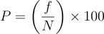
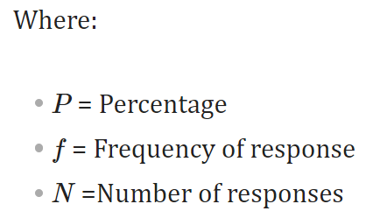
Figure 4. Percentage Formula
- Weighted Mean
The weighted mean measure shall be used to calculate the sample mean of the scores assigned as responses to the Likert-type scale questions in the survey questionnaires. Figure 5 shows the weighted sample mean formula:
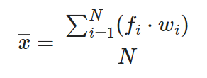
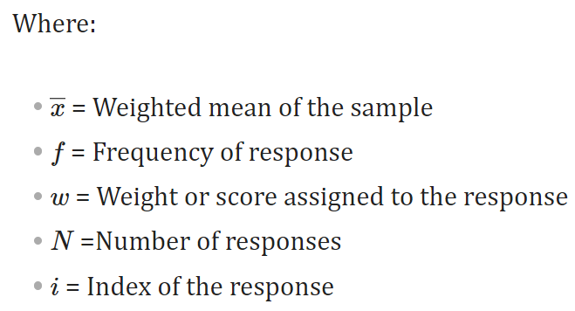
Figure 5. Weighted Mean Formula

- Standard Deviation
The standard deviation measure shall be used to calculate the variation or dispersion of the scores assigned as responses to the Likert-type scale questions in the survey questionnaires, from the scores’ weighted sample mean. Figure 6 shows the sample standard deviation formula:
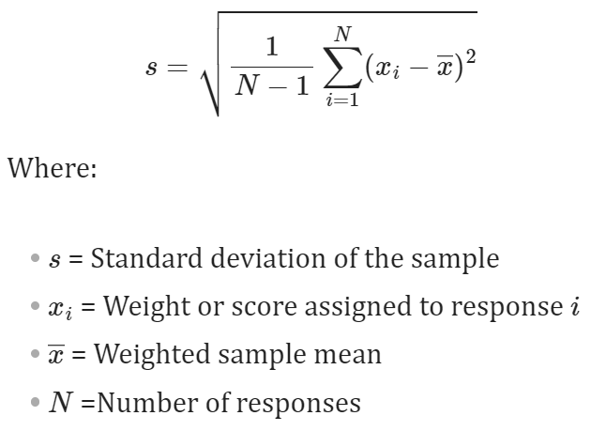
Figure 6. Standard Deviation Formula
Based on the maximum standard deviation method of Croucher (2004), the researchers use an equal-interval classification method for the standard deviation, where a “Low” standard deviation is between the interval [0, s_{max} /3], a “Medium” standard deviation is between the interval [s_{max} /3, 2 s_{max} /3], and a “High” standard deviation is between the interval [2 s_{max} /3, s_{max}]. Figure 7 shows the formula for calculating the maximum sample standard deviation over an interval, s_{max}.

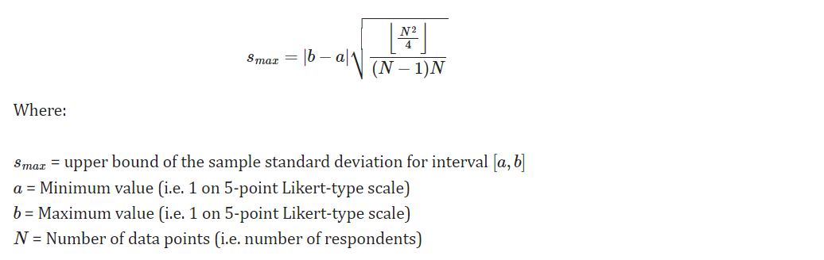
Figure 7. Maximum Sample Standard Deviation Formula

Microsoft Power BI
Microsoft Power BI is a proprietary interactive data analysis and visualization software that focuses on business intelligence. Microsoft Power BI serves as the primary quantitative data analysis and visualization software, and will be used to pre-process and analyze the survey questionnaire responses using descriptive statistics and create interactive visualization dashboards for a graphical presentation of the analysis results.
Figure 8 shows the icon of PowerBI.

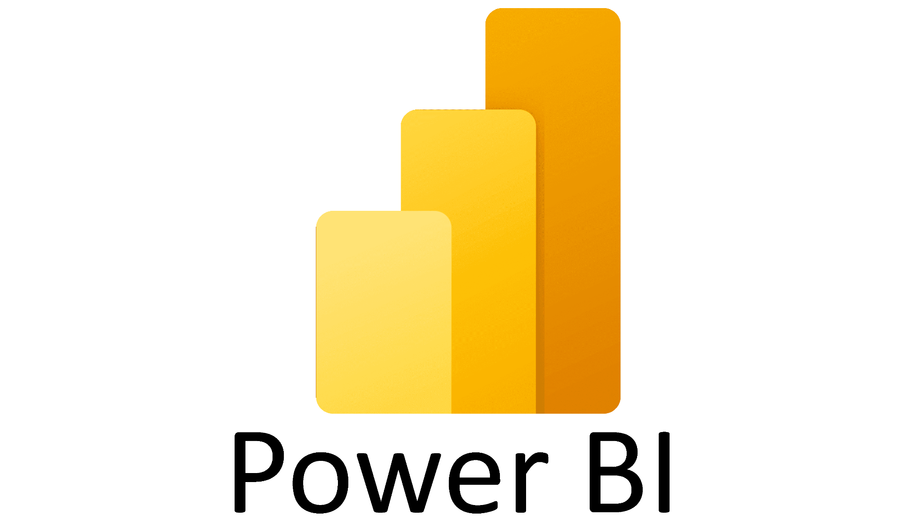
Figure 8. PowerBI

CHAPTER 4

RESULTS AND DISCUSSION
This chapter presents the analysis and interpretation of results obtained from the data collection process conducted throughout the study. The discussion is structured to discuss the response rate of the data collection, the demographic profile and the results of the pre-development survey in addressing Research Question 1 and Research Question 2, focusing on perceptions of the processes involved in student performance evaluation and monitoring among faculty members and academic administrators within the SWUNEXT cluster, as well as the identified challenges in the current student performance evaluation and monitoring processes faced by faculty members and academic administrators within the SWUNEXT cluster.

Response Rate
Out of an overall sample size of 51 faculty members and academic administrators across all colleges and schools affiliated with the SWUNEXT cluster as calculated using Cochran’s formula, 40 responses were successfully collected, resulting in an overall response rate of 78.43%. This response rate provides a robust and representative baseline for examining the existing processes and challenges encountered by faculty members and academic administrators within the SWUNEXT cluster. Table 6 shows the response rate of the study as categorized by the role of each respondent group.

Respondent Group | Sample Size | Number of Responses | Response Rate
Faculty | 41 | 36 | 87.80%
Academic Administrators | 10 | 4 | 40.00%
Total | 51 | 40 | 78.43%
Table 6. Response Rate According to Respondent Roles

Table 7 shows the response rate of the study as according to the college or department of the respondents.

Respondent Group | Sample Size | Number of Responses | Response Rate
Business School | 20 | 12 | 60.00%
College of Engineering | 4 | 4 | 100.00%
College of Information Technology | 5 | 4 | 80.00%
School of Design and Communication | 22 | 20 | 90.91%
Total | 51 | 40 | 78.43%
Table 7. Response Rate According to College / Department

Demographics
Among the thirty-six faculty respondents, nineteen (19) of the respondents are faculty members of the School of Design and Communication, eleven (11) of the respondents are faculty members of the Business School, three (3) respondents are faculty members of the College of Information Technology and three (3) respondents are faculty members of the College of Engineering. Figure 9 shows the distribution of faculty respondents by their respective college or department.
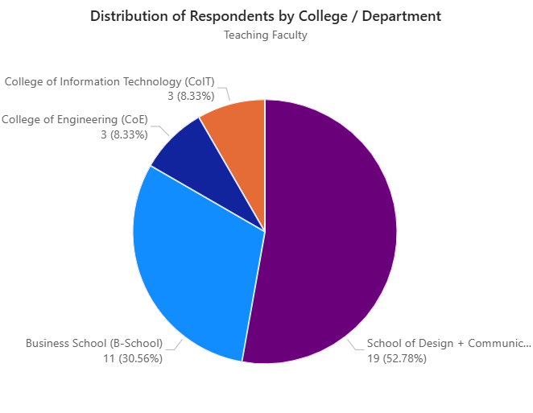
Figure 9. Distribution of Faculty Respondents by College / Department
Among the four academic administrators who completed the pre-development survey, one of the respondents is an academic administrator of the School of Design and Communication, one of the respondents is an academic administrator of the College of Engineering, one of the respondents is an academic administrator of the College of Information Technology, and one of the respondents is an academic administrator of the Business School. Figure 10 shows the distribution of academic administrator respondents by their respective college or department.
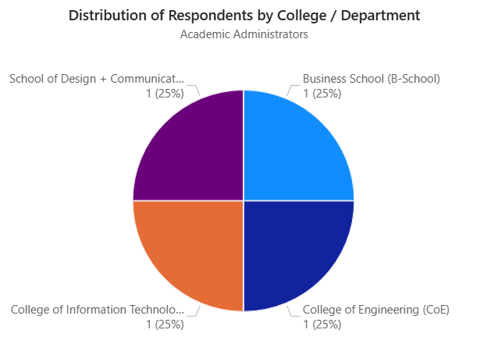
Figure 10. Distribution of Academic Administrator Respondents by College / Department
Among the four academic administrators who completed the pre-development survey, two (2) of the respondents are Program Heads, one of the respondents is a Dean,and one of the respondents is an Assistant Dean. Figure 11 shows the distribution of academic administrator respondents by their position.
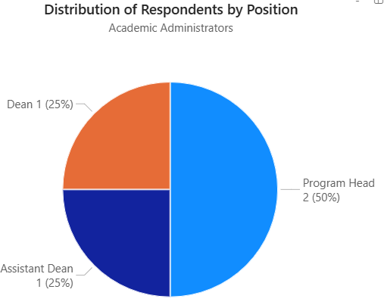
Figure 11. Distribution of Academic Administrator Respondents by Position

Processes Involved in Student Performance Evaluation and Monitoring Among SWUNEXT Faculty and Academic Administrators
The existing processes for evaluating and monitoring student performance among academic administrators of colleges and schools affiliated with the SWUNEXT cluster are analyzed using a process flow diagram, also known as a ‘flowchart’. A process flow diagram indicates the ordered sequence of operations or procedures performed in a process. The arrows in the process flow diagram represent the transition from one procedure in the process to another, while the parenthesized numeric labels on the arrows indicate the number of academic administrators who perform the procedures in the particular order or sequence indicated by the arrow. Figure 12 visualizes the current process flow performed by academic administrators of colleges and schools affiliated with the SWUNEXT cluster in assessing and monitoring student performance.
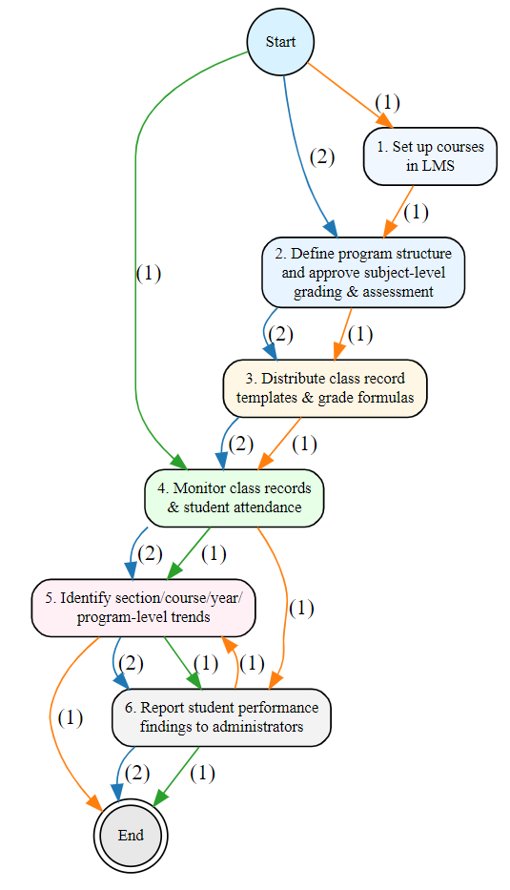
Figure 12. Current Student Performance Evaluation and Monitoring
Process Flow for Academic Administrators within SWUNEXT

The procedures being performed most frequently by academic administrators within SWUNEXT in evaluating and monitoring student performance are the monitoring of class records and student attendance reports from faculty, the identification of section/course/year/program-level trends in student performance, and the reporting of student performance findings to institutional administrators, with the highest mean scores of 4.50 (Often) and the lowest standard deviation of 0.58 (Low), which indicates a high level of agreement between academic administrators of their frequent application of these procedures, while the procedure being performed most infrequently is “Distributing access to learning management systems” with the lowest mean score of 1.50 (Rarely) and the lowest standard deviation of 0.58 (Low), which indicates a high level of agreement between academic administrators of their infrequent application of this procedure. These results suggest that academic administrators are primarily focused on late-stage monitoring and reporting phases, while the initial setup tasks are perceived as significantly less frequent. Table 8 shows the frequency in which each of the identified procedures in the current process are performed by academic administrators within SWUNEXT in evaluating and monitoring student performance.
 | Procedure | Count | Mean | Median | Mode | Standard Deviation
1. | Define program structure and approve subject-level grading and assessment policies | 4 | 2.00 | 2.00 | 2 | 0.82
2. | Distribute access to classes in learning management systems | 4 | 1.50 | 1.50 | 1 | 0.58
3. | Distribute class record templates and grade calculation formulas | 4 | 2.00 | 2.00 | 2 | 0.82
4. | Monitor class records and student attendance reports from faculty | 4 | 4.50 | 4.50 | 4 | 0.58
5. | Identify section/course/year/  program-level trends in student performance | 4 | 4.50 | 4.50 | 4 | 0.58
6. | Report student performance findings to institutional administrators | 4 | 4.50 | 4.50 | 4 | 0.58
Table 8. Frequency of Each Procedure in the Student Performance Evaluation
and Monitoring Process for Academic Administrators within SWUNEXT
The existing processes for evaluating and monitoring student performance among the faculty members of colleges and schools affiliated with the SWUNEXT cluster are analyzed using an incidence matrix. An incidence matrix indicates a relationship or correspondence between two objects, in this case, the correspondence between the operations or procedures performed in the current student performance evaluation and monitoring process and their relative order for each faculty’s process flow. The columns indicate the relative order in which a procedure is performed (e.g. 1st to 12th in the process) while the numeric cell entries indicate the number of faculty members who assign the particular procedure to the particular order in their process flow. The entries in the N/A column indicate that the particular procedure is not performed in a faculty member’s current student performance evaluation and monitoring process flow. Table 9 suggests that the most common sequence of procedures performed by faculty members of colleges and schools affiliated with the SWUNEXT cluster are the definition of student assessment methods and assessment-level grading criteria, setup of courses in learning management systems, delivery of course instruction, collection and recording of student attendance and engagement data, conduct of student check-ups or observations, delivery of student assessments and checking of assessment outputs, recording of student assessment results to class records, calculation of student grades after assessment results, identification and/or prediction of student performance trends, monitoring of performance of students who are at risk of failure, conduct of student intervention measures, and lastly, the creation and submission of student performance reports. The incidence matrix suggests the overall linear progression of student performance evaluation and monitoring tasks, yet the wide dispersion in check-ups and observation suggests an inconsistent approach to student observation. Table 9 visualizes the incidence matrix showing the current spectrum of process flows performed by academic administrators of colleges and schools affiliated with the SWUNEXT cluster in assessing and monitoring student performance.

Procedure | 1st | 2nd | 3rd | 4th | 5th | 6th | 7th | 8th | 9th | 10th | 11th | 12th | N/A
Define student assessment methods and assessment-level grading criteria | 22 | 1 |  |  | 3 | 1 |  |  |  | 1 |  |  | 8
Set up course in learning management system | 3 | 22 |  |  | 1 |  | 1 | 1 |  |  |  |  | 8
Deliver course instruction (e.g. teacher-led or student-led) | 8 | 4 | 22 | 1 | 1
Collect and record student attendance and engagement data | 1 | 7 | 3 | 20 | 3 | 1 | 1
Perform student check-ups or observations | 1 |  | 5 | 2 | 16 | 2 |  | 1 | 2 | 3 | 2 | 2
Deliver student assessments and check assessment outputs | 1 |  | 3 | 6 | 4 | 19 |  | 3
Record student assessment results to class records | 1 |  | 1 | 4 | 6 | 5 | 18 |  | 1
Calculate student grades after assessment results | 1 |  |  |  | 4 | 6 | 5 | 18 |  | 2
Identify and/or forecast student performance trends |  |  |  |  |  | 2 | 7 | 4 | 17 |  | 3 |  | 3
Monitor the performance of students who are at risk of failure |  | 1 |  |  |  | 2 | 1 | 7 | 7 | 17 | 1
Perform student interventions |  |  |  | 1 | 2 | 2 | 1 | 1 | 6 | 4 | 18 | 1
Write and submit student performance reports |  |  |  |  | 1 | 4 | 2 | 1 | 1 | 7 | 3 | 17
Table 9. Incidence Matrix of Current Student Performance Evaluation
and Monitoring Process Flow for Faculty Members within SWUNEXT
The procedure being performed most frequently by faculty members within SWUNEXT in evaluating and monitoring student performance is the collection and recording of student attendance and engagement data, with a mean score of 4.97 (Always), while the procedure being performed least frequently by faculty members within SWUNEXT in evaluating and monitoring student performance is the identification and prediction of student performance trends, with a mean score of 3.54 (Often). These results suggest that although the faculty members perform all the procedures relatively frequently, they prioritize the attendance, instruction, assessment, checking, recording and student performance reporting, while showing the lowest frequency in proactive monitoring tasks such as forecasting student performance trends and conducting student interventions. Table 10 shows the frequency in which each of the identified procedures in the current process are performed by academic administrators within SWUNEXT in evaluating and monitoring student performance.
 | Procedure | Count | Mean | Median | Mode | Standard Deviation
1. | Define student assessment methods and assessment-level grading criteria | 28 | 4.32 | 5.00 | 5 | 0.98
2. | Set up course in learning management system | 29 | 4.00 | 4.00 | 5 | 1.16
3. | Deliver course instruction (e.g. teacher-led or student-led) | 34 | 4.88 | 5.00 | 5 | 0.33
4. | Collect and record student attendance and engagement data | 34 | 4.97 | 5.00 | 5 | 0.17
5. | Perform student check-ups or observations | 34 | 3.82 | 4.00 | 3 | 0.94
6. | Deliver student assessments and check assessment outputs | 33 | 4.85 | 5.00 | 5 | 0.36
7. | Calculate student grades after assessment results | 33 | 4.70 | 5.00 | 5 | 0.53
8. | Record student assessment results to class records | 33 | 4.82 | 5.00 | 5 | 0.46
9. | Identify and/or forecast student performance trends | 33 | 3.54 | 3.00 | 3 | 0.97
10. | Monitor the performance of students who are at risk of failure | 34 | 4.06 | 4.00 | 4 | 0.89
11. | Perform student interventions | 34 | 3.65 | 4.00 | 3 | 1.10
12. | Write and submit student performance reports | 34 | 4.91 | 5.00 | 5 | 0.29
Table 10. Frequency of Each Procedure in the Student Performance Evaluation
and Monitoring Process for Faculty Members within SWUNEXT

Summary of Findings Related to Research Question 1
The findings for Research Question 1 indicate that the existing student performance evaluation and monitoring processes within the SWUNEXT cluster follow a linear and sequential process flow where faculty members prioritize the initial components of the process flow such as attendance and engagement monitoring, instruction delivery, and checking and recording of assessment results over proactive monitoring of student performance indicators, while academic administrators prioritize the terminal components of the process flow such as monitoring student performance, identification of performance trends, and reporting, suggesting an inconsistent approach to student performance evaluation and monitoring.

Challenges in Student Performance Evaluation and Monitoring Among SWUNEXT Faculty and Academic Administrators
The results in Table 11 suggest that the lack of integration between the different platforms currently used for student performance monitoring is the foremost challenge reported by academic administrators, with a mean score of 4.50 (Strongly Agree). This is followed by difficulty comparing student performance across courses, sections, year levels, and degree programs, with a mean score of 4.25 (Agree), and difficulty accessing performance data when needed in unstable or disrupted situations, with a mean score of 4.00 (Agree). Academic administrators expressed a neutral perception regarding difficulty in early identification and categorization of at-risk students. Table 11 summarizes these responses.
 | Statement | Count | Mean | Median | Mode | Standard Deviation
a. | Existing systems used in assessing and monitoring student performance lack integration with each other. | 4 | 4.50 | 5.00 | 5 | 1.00
b. | It is difficult to compare student performance across different courses (i.e. subjects), sections, year levels, and degree programs. | 4 | 4.25 | 4.50 | 5 | 0.96
c. | It is difficult to access student performance data when needed in situations involving unstable Internet connections, accidentally deleted files, faculty absences, etc. | 4 | 4.00 | 4.00 | 3 | 1.16
d. | It is difficult to obtain timely reports. | 4 | 4.00 | 4.00 | 4 | 0.00
e. | It is difficult to identify students at risk of failure early in a semester. | 4 | 3.25 | 3.50 | 1 | 1.71
f. | It is difficult to categorize students based on their performance levels (e.g., high, average, at-risk). | 4 | 3.00 | 3.50 | 4 | 1.41
Table 11. Challenges in Student Performance Evaluation and Monitoring
Among Academic Administrators within SWUNEXT
The results in Table 12 suggest that difficulty consolidating student performance data from different sources is the foremost challenge reported by faculty members, with a mean score of 4.33 (Agree), followed by time-consuming management of student performance records, with a mean score of 4.28 (Agree). Faculty members also agreed that existing systems lack useful analytical insights and that identifying at-risk students and monitoring student progress are challenging, each with a mean score of 4.08. Table 12 summarizes these responses.
 | Statement | Count | Mean | Median | Mode | Standard Deviation
a. | Data consolidation from different sources is difficult. | 36 | 4.33 | 4 | 5 | 0.72
b. | Managing student performance records is time-consuming. | 36 | 4.28 | 4 | 4 | 0.51
c. | Existing systems lack useful insights. | 36 | 4.08 | 4 | 4 | 0.65
d. | Identifying at-risk students is challenging. | 36 | 4.08 | 4 | 4 | 0.65
e. | Monitoring student progress is difficult. | 36 | 4.08 | 4 | 4 | 0.69
f. | There are instances of errors or inconsistencies in student academic records. | 36 | 3.94 | 4 | 4 | 0.58
g. | Data interpretation requires too much time. | 36 | 3.89 | 4 | 4 | 0.67
h. | Data security and privacy is a significant risk with the current student performance monitoring process. | 36 | 3.89 | 4 | 4 | 0.71
Table 12. Challenges in Student Performance Evaluation and
Monitoring Among Faculty Members within SWUNEXT

Summary of Findings Related to Research Question 2
The findings identify fragmentation and data consolidation as the strongest operational problems in the current student performance monitoring process. Faculty members also report difficulty obtaining useful insights, monitoring progress, and identifying at-risk students, while academic administrators emphasize cross-class comparison and timely reporting. These findings support a centralized monitoring system that reduces the need to reconcile separate records. Within that system, the AI component is deliberately focused on performance prediction and the prioritization of students who may require faculty attention; it supplements, rather than replaces, the system’s record-management and analytical functions.

Conceptual Framework
The proposed AI-Based Student Performance Evaluation and Monitoring System follows a linear-iterative input-process-output approach. The system continuously updates calculated monitoring indicators and AI-assisted outputs when authorized performance records or evaluation criteria are added or modified. It is accessible through a web-based user interface connected to the system backend and is designed primarily for Faculty, Academic Admin, and System Admin users.
The input process begins with authenticated access, class and roster setup, and configuration of authorized grading or evaluation criteria. Faculty members then encode or import assessment results, attendance, participation, and other relevant performance indicators. Data may be entered manually or through supported file imports, with approved Learning Management System integration treated as optional where institutional authorization and technical access are available. The system validates and stores the records, calculates each student’s current or provisional academic standing, and supplies selected indicators to the AI prediction component. The AI component produces performance predictions and at-risk classifications and may provide explanations of the indicators that contributed most strongly to the result. These outputs are displayed in dashboards and reports for faculty review. Faculty members may then record interventions or send reviewed feedback to students. Official grade submission to SWU SIS remains a separate institutional process outside the proposed system.
Figure 13 illustrates the proposed system’s conceptual framework in the context of the system inputs and outputs, using the Input-Process Output model.
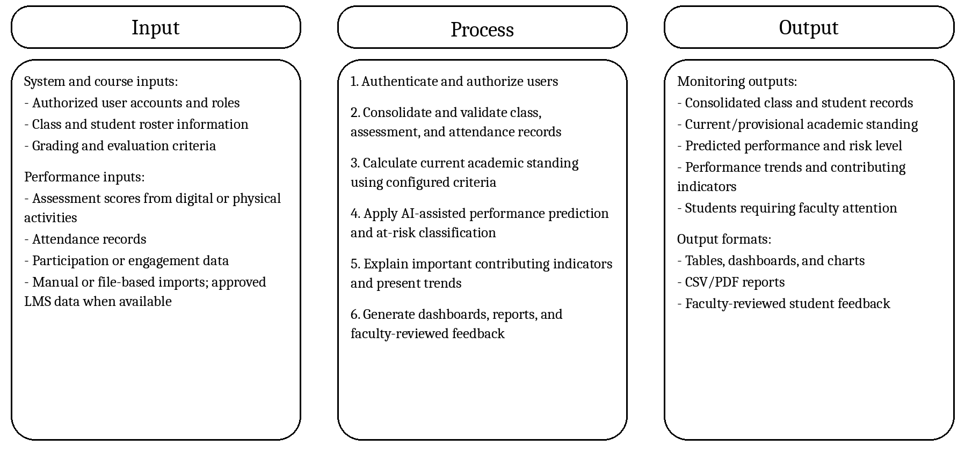
Figure 13. Conceptual Framework of the System Using the Input-Process-Output Model

Context Flow Diagram
A context flow diagram illustrates the overall flow of a system, and its inputs, outputs, and interactions with external entities. Figure 14 shows the context flow diagram of the proposed system.
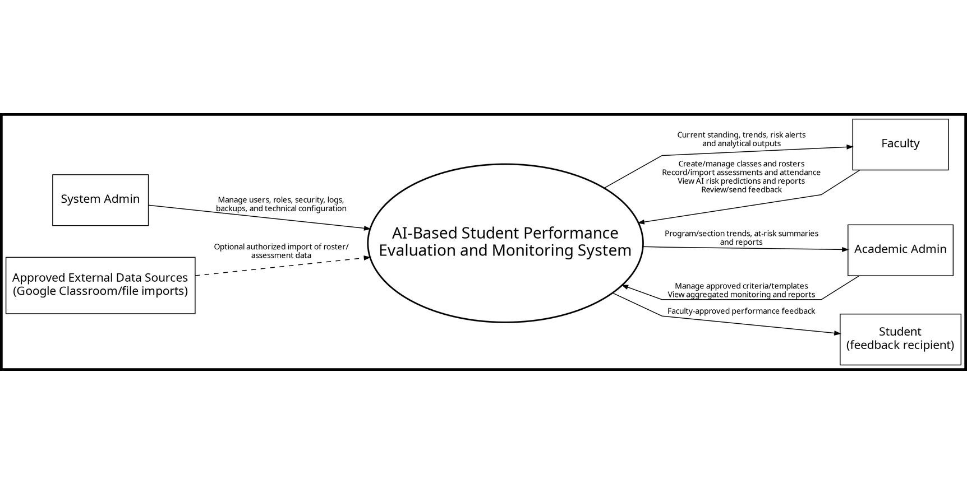
Figure 14. Context Flow Diagram
The context flow diagram shows the interactions between the proposed system and its primary user roles: Faculty, Academic Admin, and System Admin. Faculty members manage their classes and rosters, encode or import assessment and attendance data, review calculated current standing, view AI-assisted risk predictions, and generate reports or feedback. Academic Admin users, including deans, assistant deans, program directors, program chairs, and program heads as applicable, view authorized aggregated monitoring information and manage approved evaluation criteria or templates. The System Admin manages user accounts, roles, security settings, logs, backups, and technical configuration. Students are treated as beneficiaries or feedback recipients and do not require a system account in the minimum viable implementation. Approved external learning-platform or file-based sources may provide optional input data, subject to institutional authorization.

Use- case Diagram
A use-case diagram is a type of Unified Modeling Language (UML) diagram that visualizes a system’s high-level functionality and the interactions between users and the system (Mornie et al., 2026). Figure 15 presents the revised use cases for the proposed AI-Based Student Performance Evaluation and Monitoring System according to the clarified system scope.
The system uses three primary authenticated roles: System Admin, Academic Admin, and Faculty. System Admin combines the technical responsibilities previously separated between Super Admin and System Admin and manages users, roles, permissions, logs, backups, and security configuration. Academic Admin represents authorized academic leaders such as deans, assistant deans, program directors, program chairs, and program heads; this role focuses on aggregated monitoring, reports, and approved evaluation criteria or templates. Faculty is the primary operational role and manages classes, rosters, assessment results, attendance, current-standing calculations, AI-assisted performance prediction, at-risk review, and faculty-approved feedback. The separate Grader role is removed because assessment-result entry is treated as a Faculty responsibility in the minimum viable workflow. Students may receive approved feedback but are not required to authenticate into the system. RBAC enforces these responsibilities according to least-privilege principles.
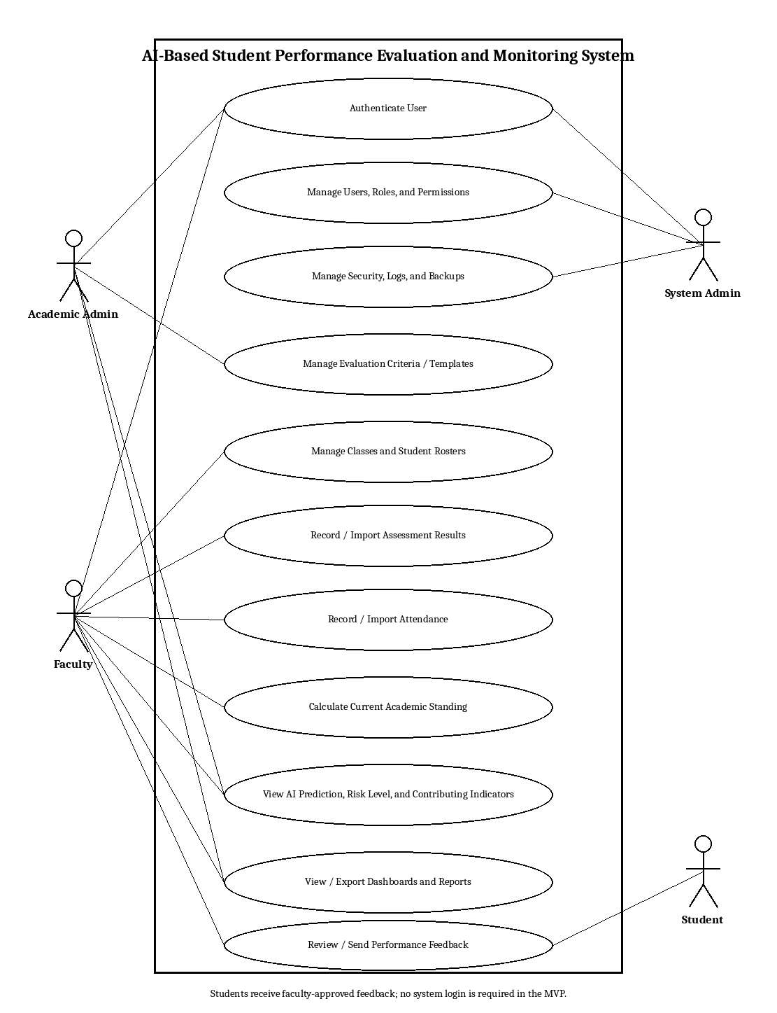
Figure 15. Use Case Diagram

Data Flow Diagram
According to Napolitano et al. (2024), a data flow diagram (DFD) visualizes the movement of data through a system, including external entities, processes, and data stores. In the proposed system, authenticated faculty users create or import class and roster information, assessment scores, attendance, participation, and related records. These records are stored in centralized data stores and processed by the grade-calculation module to generate current academic standing. Selected indicators are then processed by the AI module to produce performance predictions and at-risk classifications. Dashboards and reports retrieve calculated and predicted results for Faculty and Academic Admin users, while faculty-reviewed feedback may be communicated to students. System Admin functions maintain accounts, permissions, logs, backups, and technical settings. Direct official-grade submission to SWU SIS is outside this data flow.

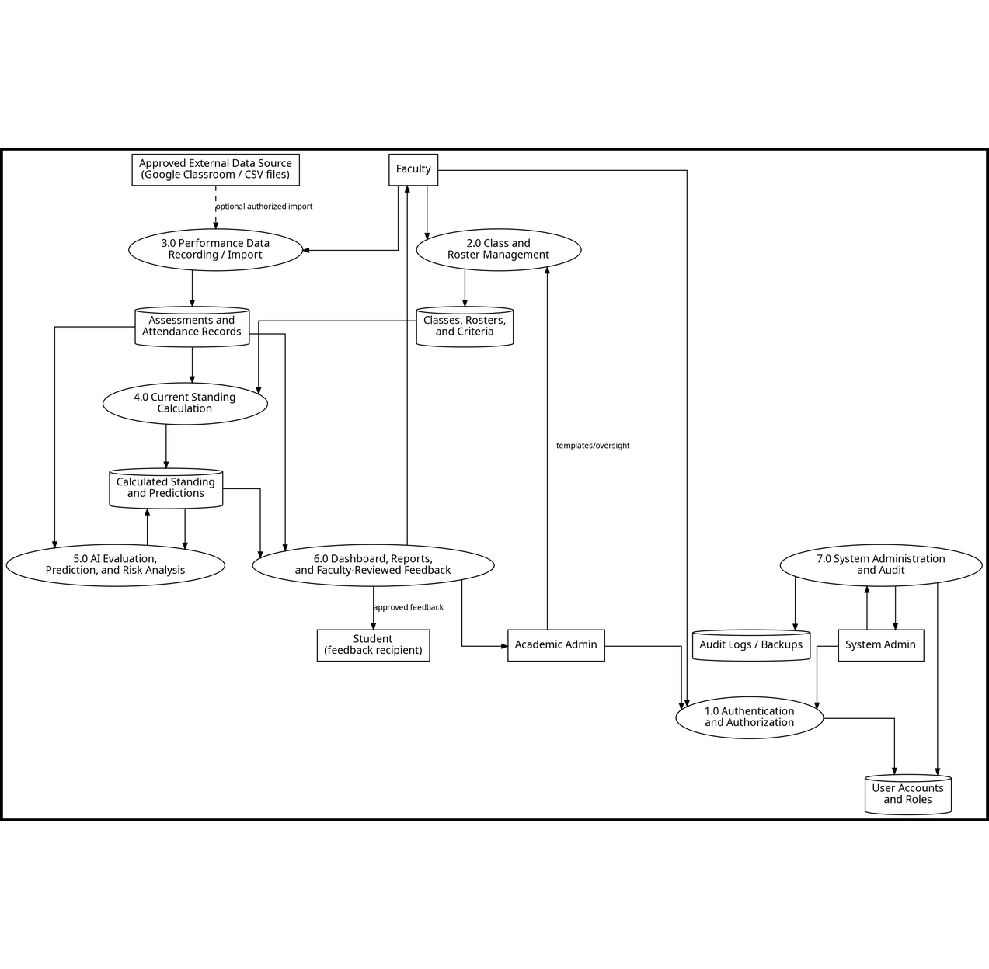
Figure 16. Data Flow Diagram

WIREFRAMES

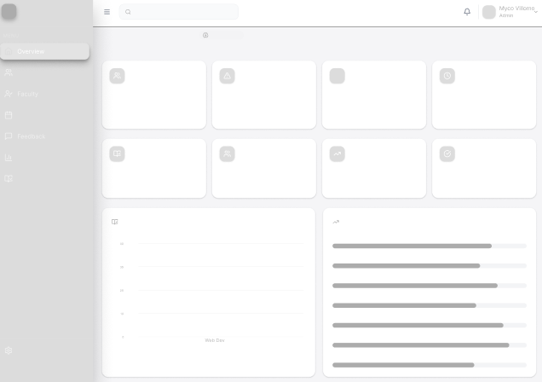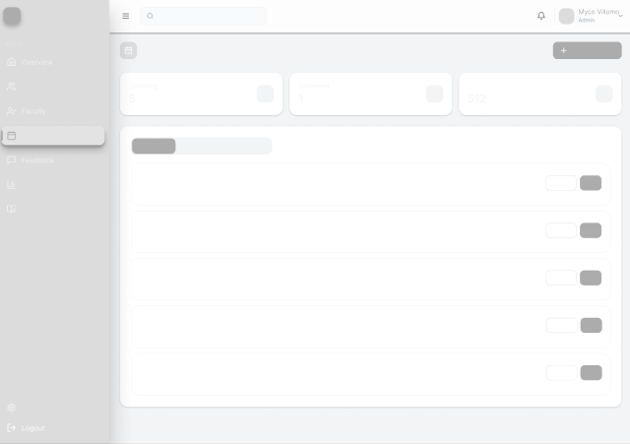
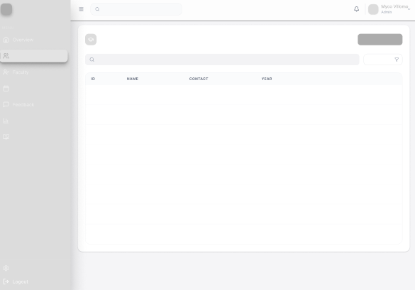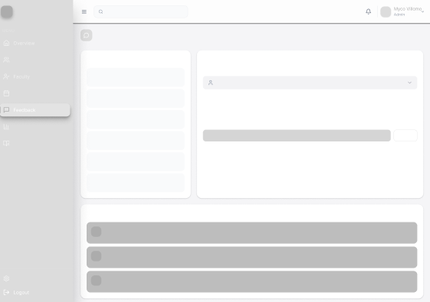
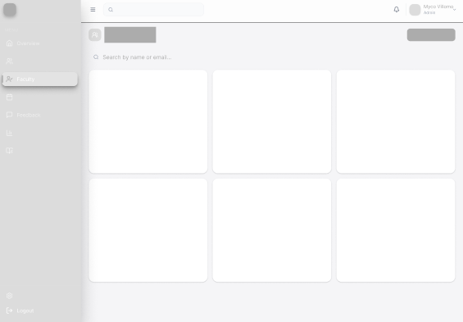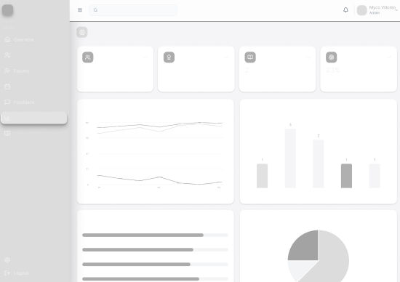
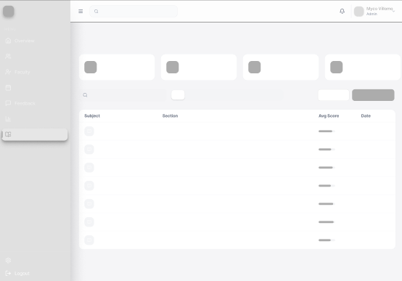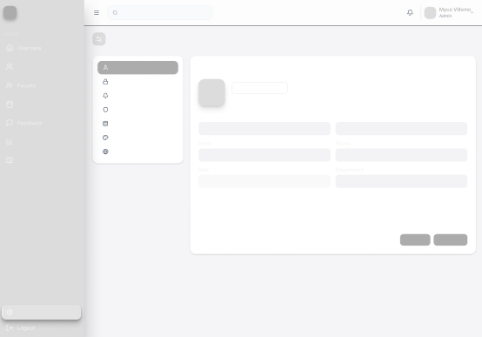
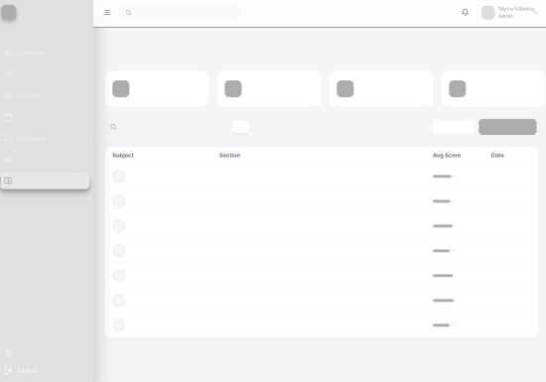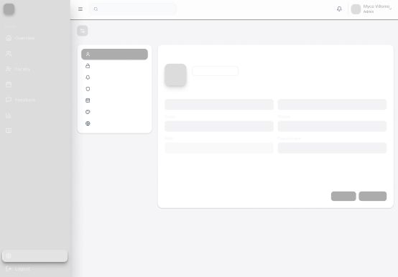
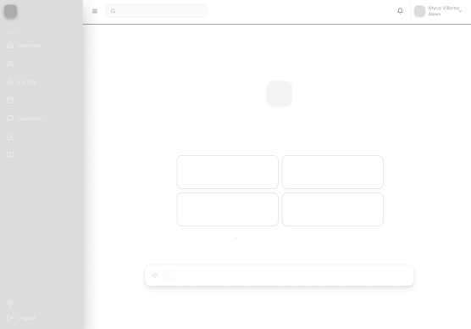

MOCKUPS
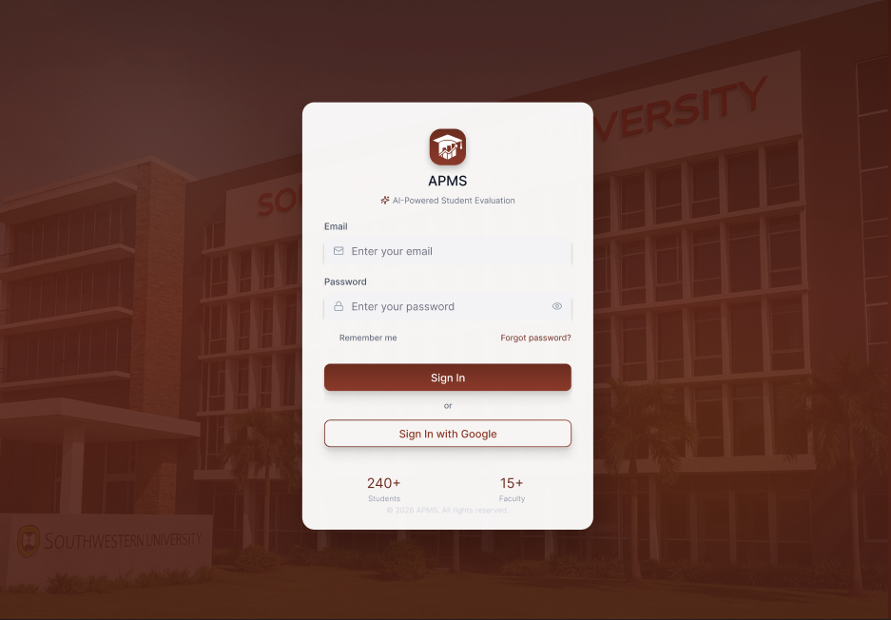

LOGIN PAGE
The figure above illustrates the Login page of the AI-Based Student Performance Evaluation and Monitoring System. The page provides secure access for System Admin, Academic Admin, and Faculty users. Academic users may authenticate using an authorized PHINMAEd account through Google sign-in where organizational policies permit, while an email/password-based method may be retained as a controlled fallback. Authentication is followed by role-based redirection to the appropriate dashboard. Student login is not required in the minimum viable workflow because students receive faculty-approved feedback outside the administrative interface.
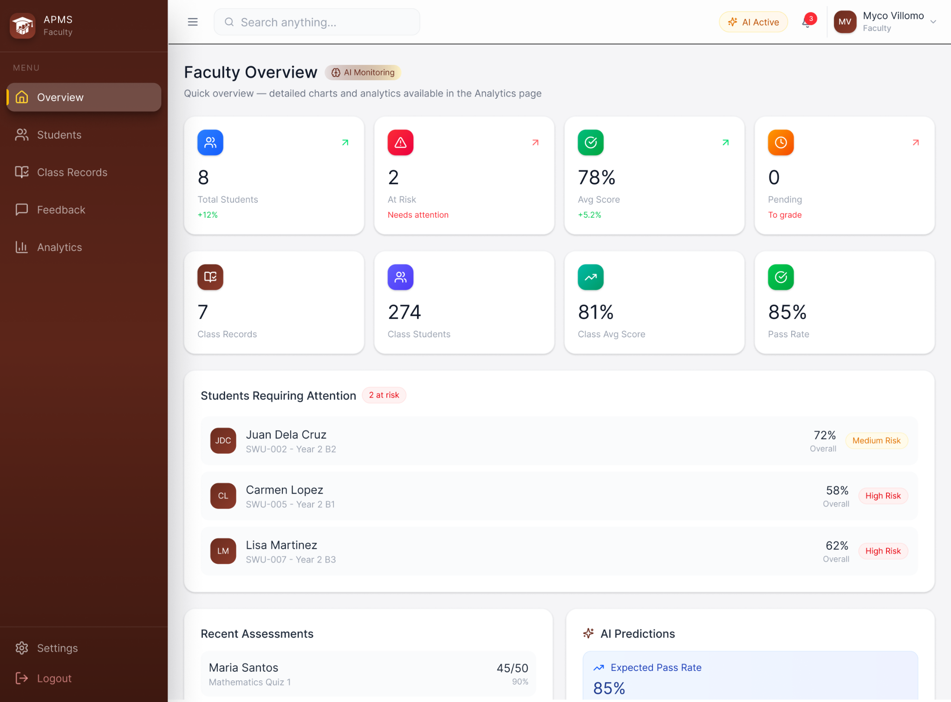
FACULTY - OVERVIEW DASHBOARD
The figure above shows the Faculty Overview Dashboard, which is the primary monitoring workspace of the proposed system. It summarizes the faculty member’s classes, average current standing, students requiring attention, recent assessments, attendance indicators, and AI-assisted risk or performance predictions. The Students Requiring Attention panel prioritizes students according to configurable risk indicators so that faculty can quickly review which students may need intervention. Dashboard values represent monitoring information and provisional calculations rather than official SIS grades.
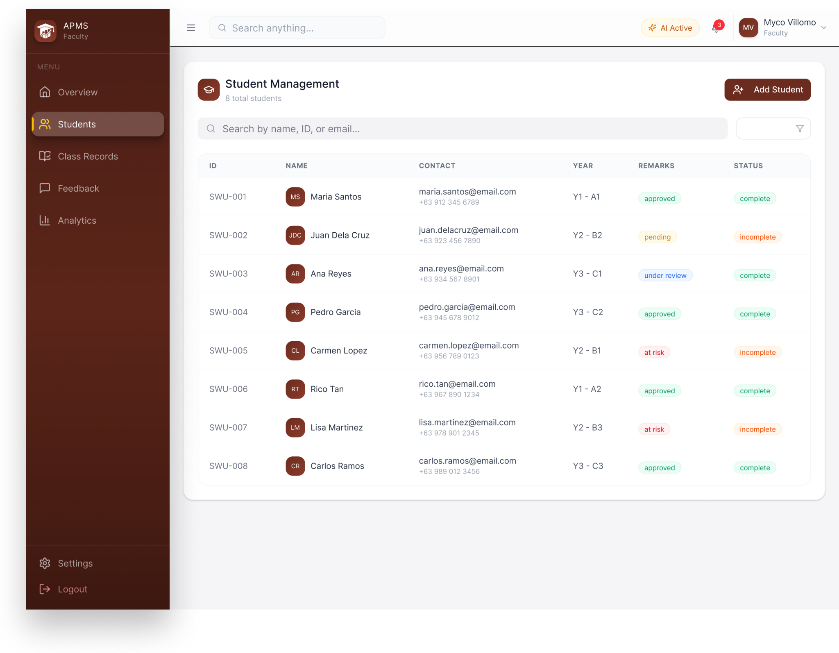
FACULTY - STUDENT ROSTER AND MONITORING PAGE
The figure above shows the Faculty Student Roster and Monitoring page. It provides a searchable and sortable roster of students associated with the faculty member’s class records. Faculty may add or import the minimum student information required for monitoring, such as student ID, name, institutional email when authorized, program or year information, and section. Selecting a student opens their assessment history, attendance summary, current standing, performance trend, and AI-assisted risk information. The page is intended for local monitoring and does not replace the authoritative student profile maintained in SWU SIS.
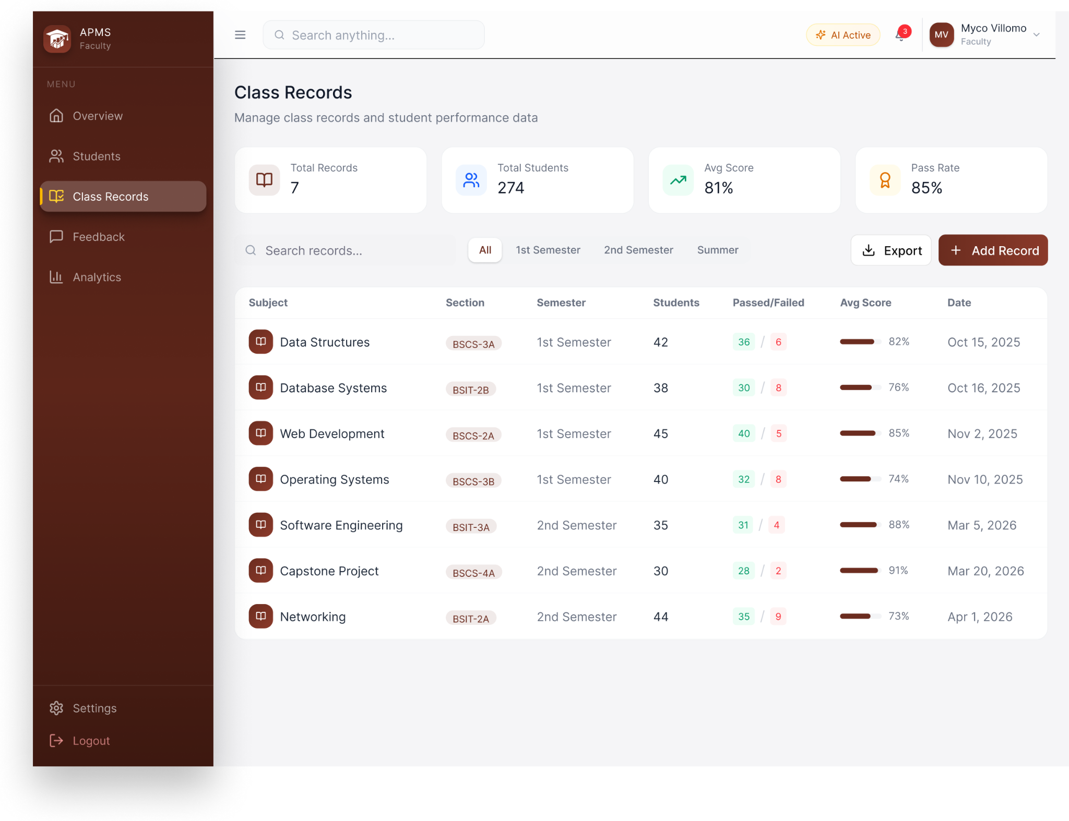
FACULTY - CLASS RECORDS PAGE
The figure above shows the Class Records page, where faculty manage the performance data used by the monitoring system. A class record contains the subject, section, academic period, roster, evaluation criteria, assessment items, scores, and attendance records. Assessment items may represent Google Classroom or Google Forms activities, physical written works, quizzes, examinations, projects, or other course requirements. Records can be encoded manually or imported from supported files, while direct Google Classroom synchronization is optional and dependent on institutional authorization. The system calculates current or provisional standing and provides summaries such as class average, passing-risk indicators, and performance trends; official grades remain outside the system.
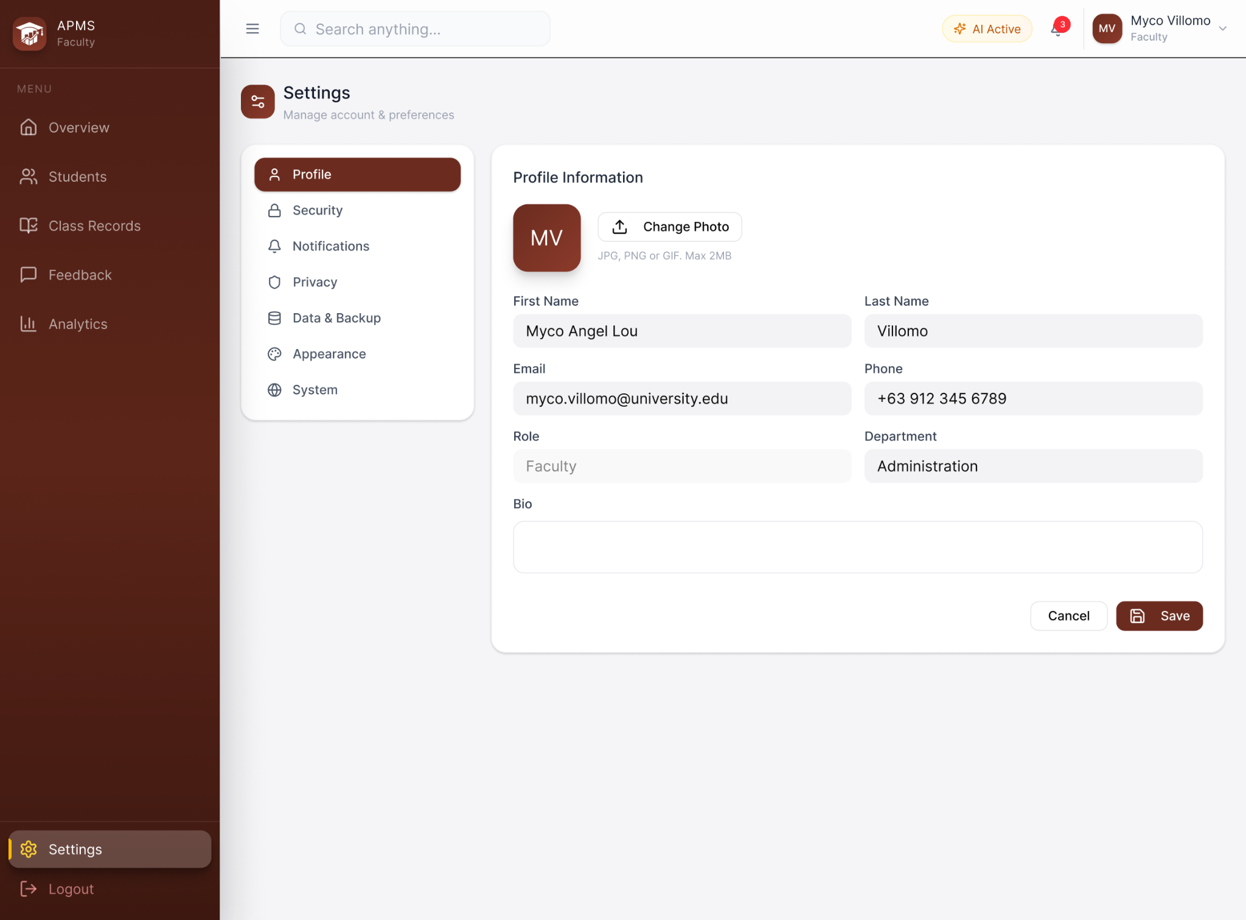
FACULTY - SETTINGS PAGE
The figure above shows the Settings page, which provides role-appropriate controls for profile information, authentication and account security, notifications, and privacy preferences. Faculty users may manage their own profile and notification preferences, while system-level backup, restoration, access-control, and technical configuration remain restricted to the System Admin role. Sensitive changes require validation and confirmation.
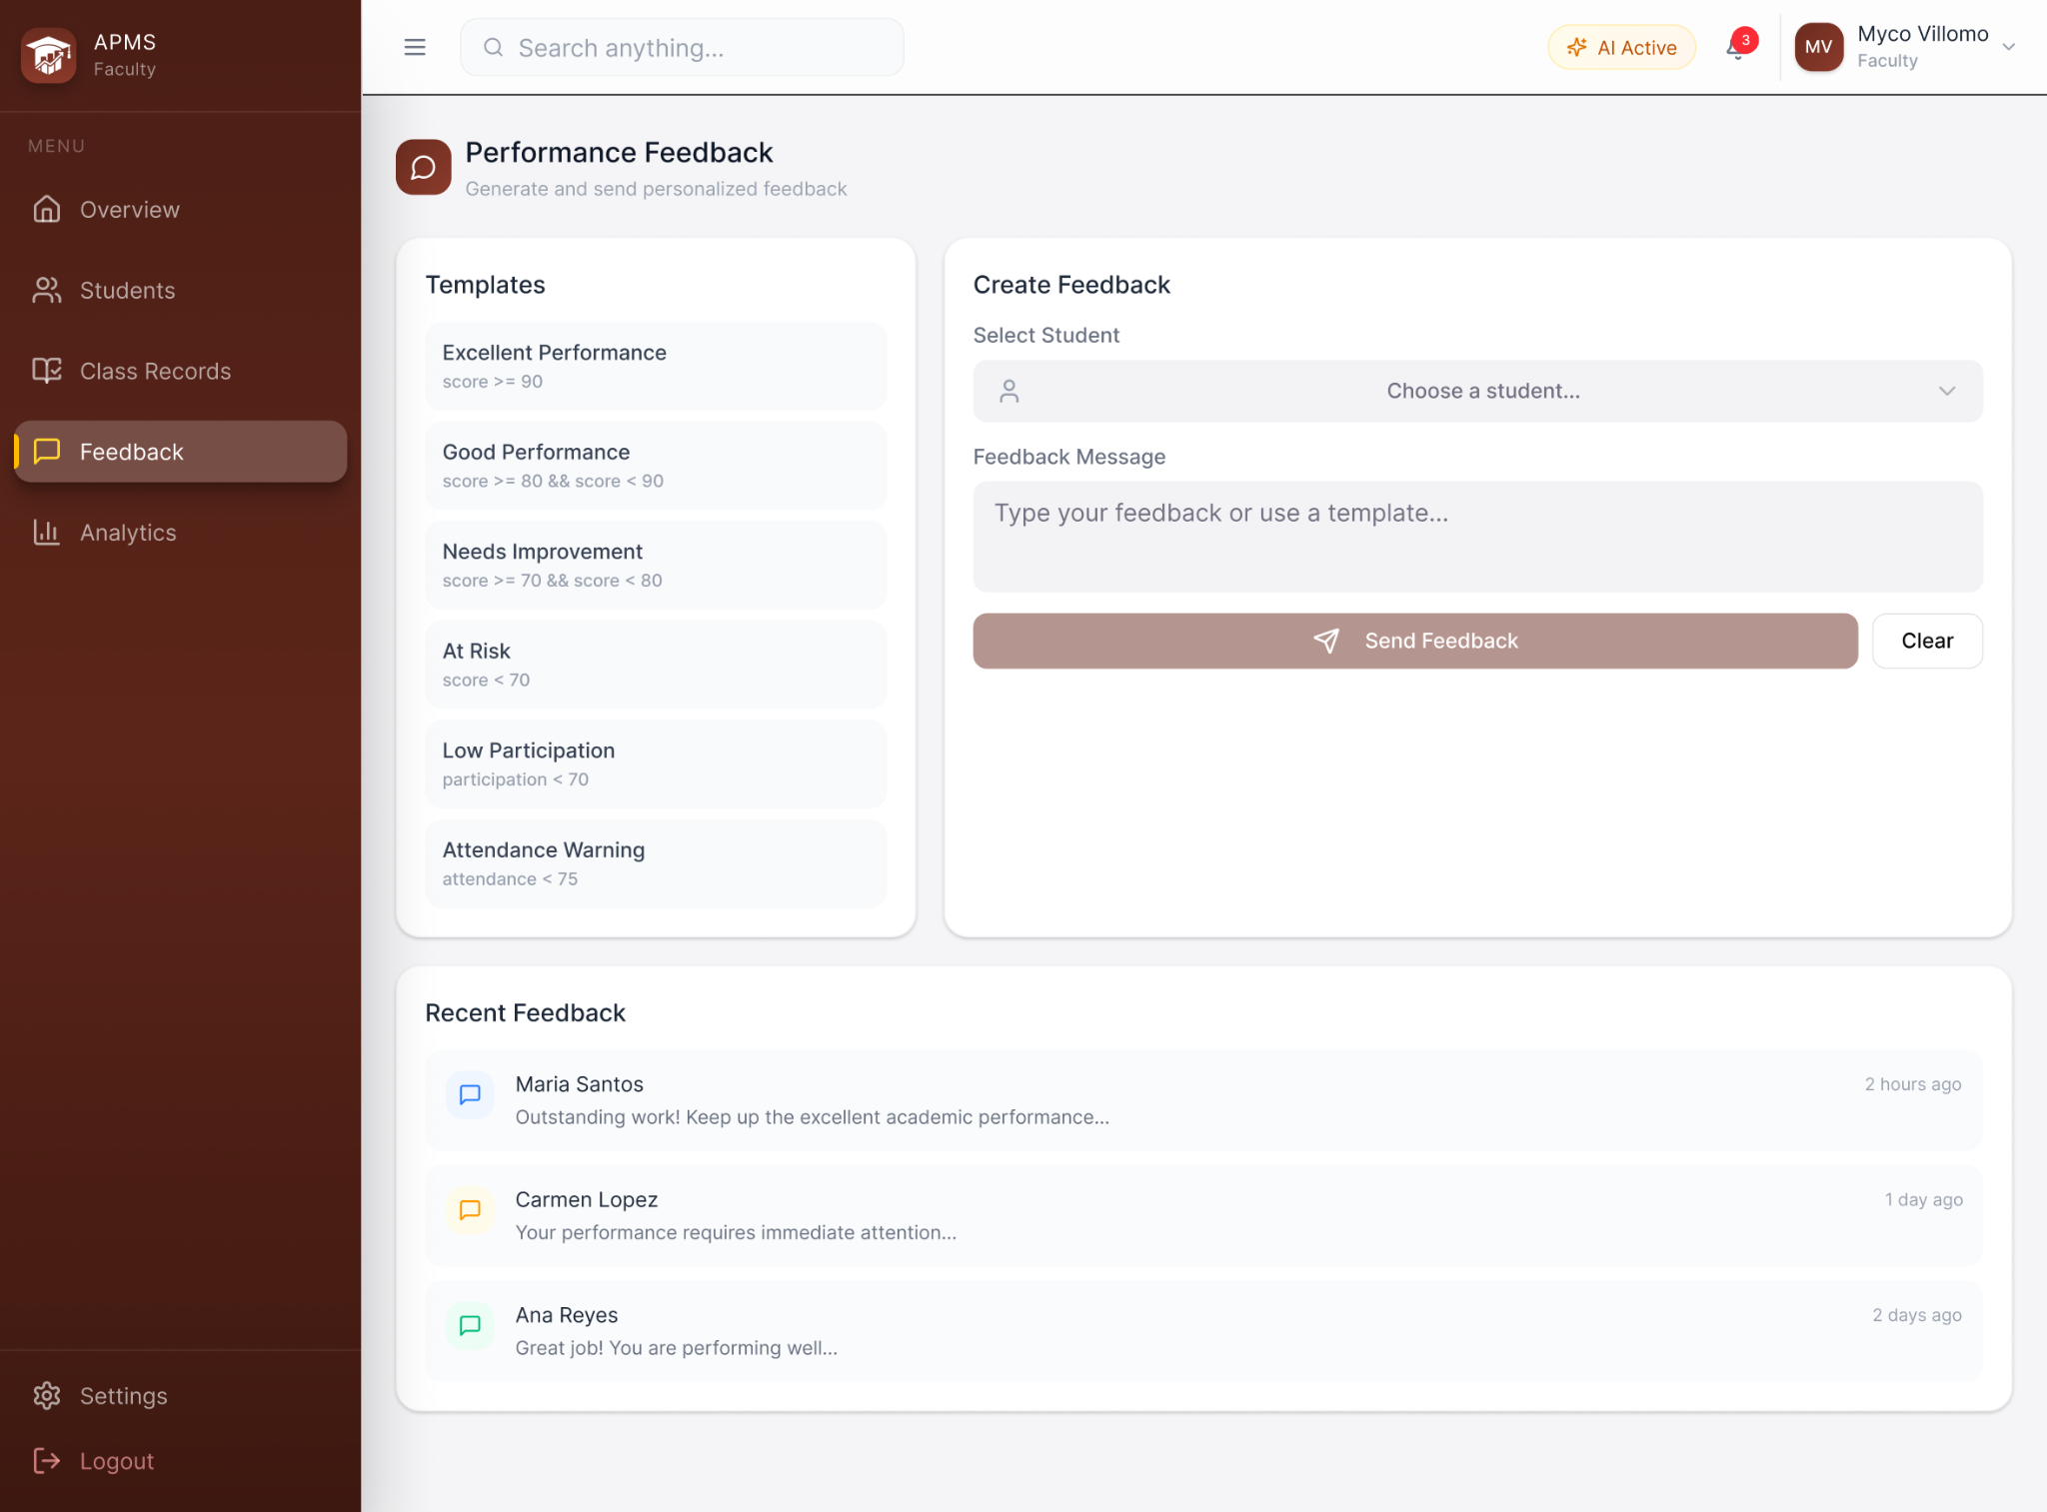
FACULTY - PERFORMANCE FEEDBACK PAGE
The figure above shows the Performance Feedback page. Faculty may review a student’s monitoring indicators, select or edit a feedback template, and optionally use AI-assisted wording to draft a performance summary. Any generated feedback remains editable and must be reviewed by the faculty member before being sent or communicated to the student. A feedback history supports traceability, while the system does not automatically impose interventions or make academic decisions.
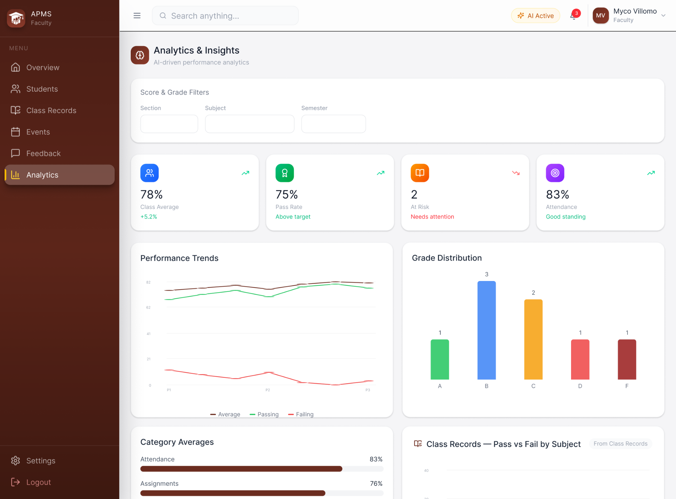
FACULTY - ANALYTICS & INSIGHTS PAGE
The figure above illustrates the Analytics & Insights page. It presents class and student performance using summary cards, tables, and charts that can be filtered by subject, section, date range, assessment category, attendance, risk level, or student. The page visualizes current-standing trends, grade distributions, attendance patterns, recent assessment results, and at-risk groups identified by the AI module. Reports may be exported for authorized monitoring and administrative use.
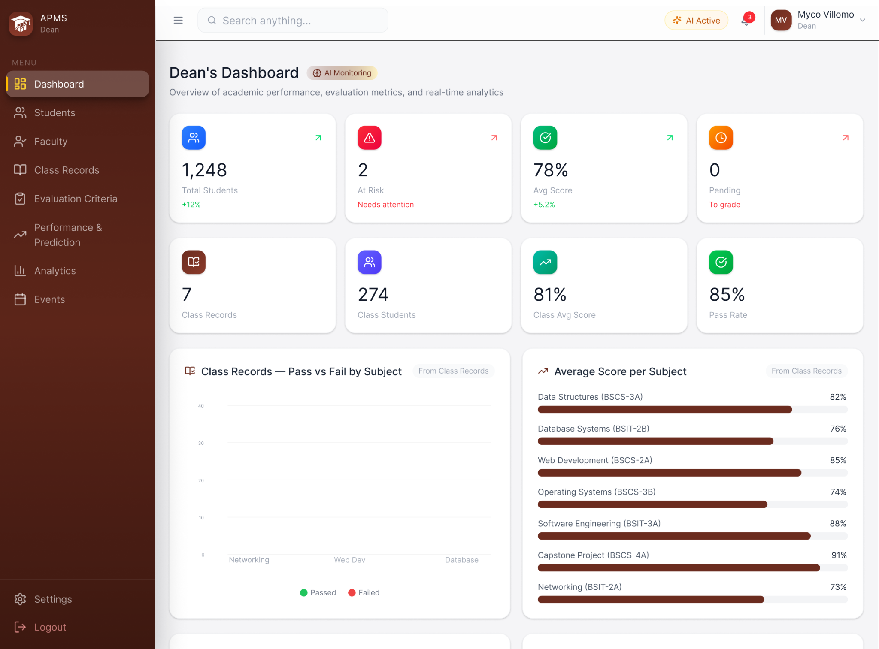
ACADEMIC ADMIN - OVERVIEW DASHBOARD
The figure above illustrates the Academic Admin Overview Dashboard. Academic Admin users represent authorized academic leaders such as deans, assistant deans, program directors, program chairs, and program heads. The dashboard provides aggregated, role-authorized information across relevant classes, sections, courses, or programs, including performance distributions, pass-risk summaries, attendance trends, and at-risk cohorts. The role is intended for oversight and comparison rather than routine editing of faculty assessment scores.
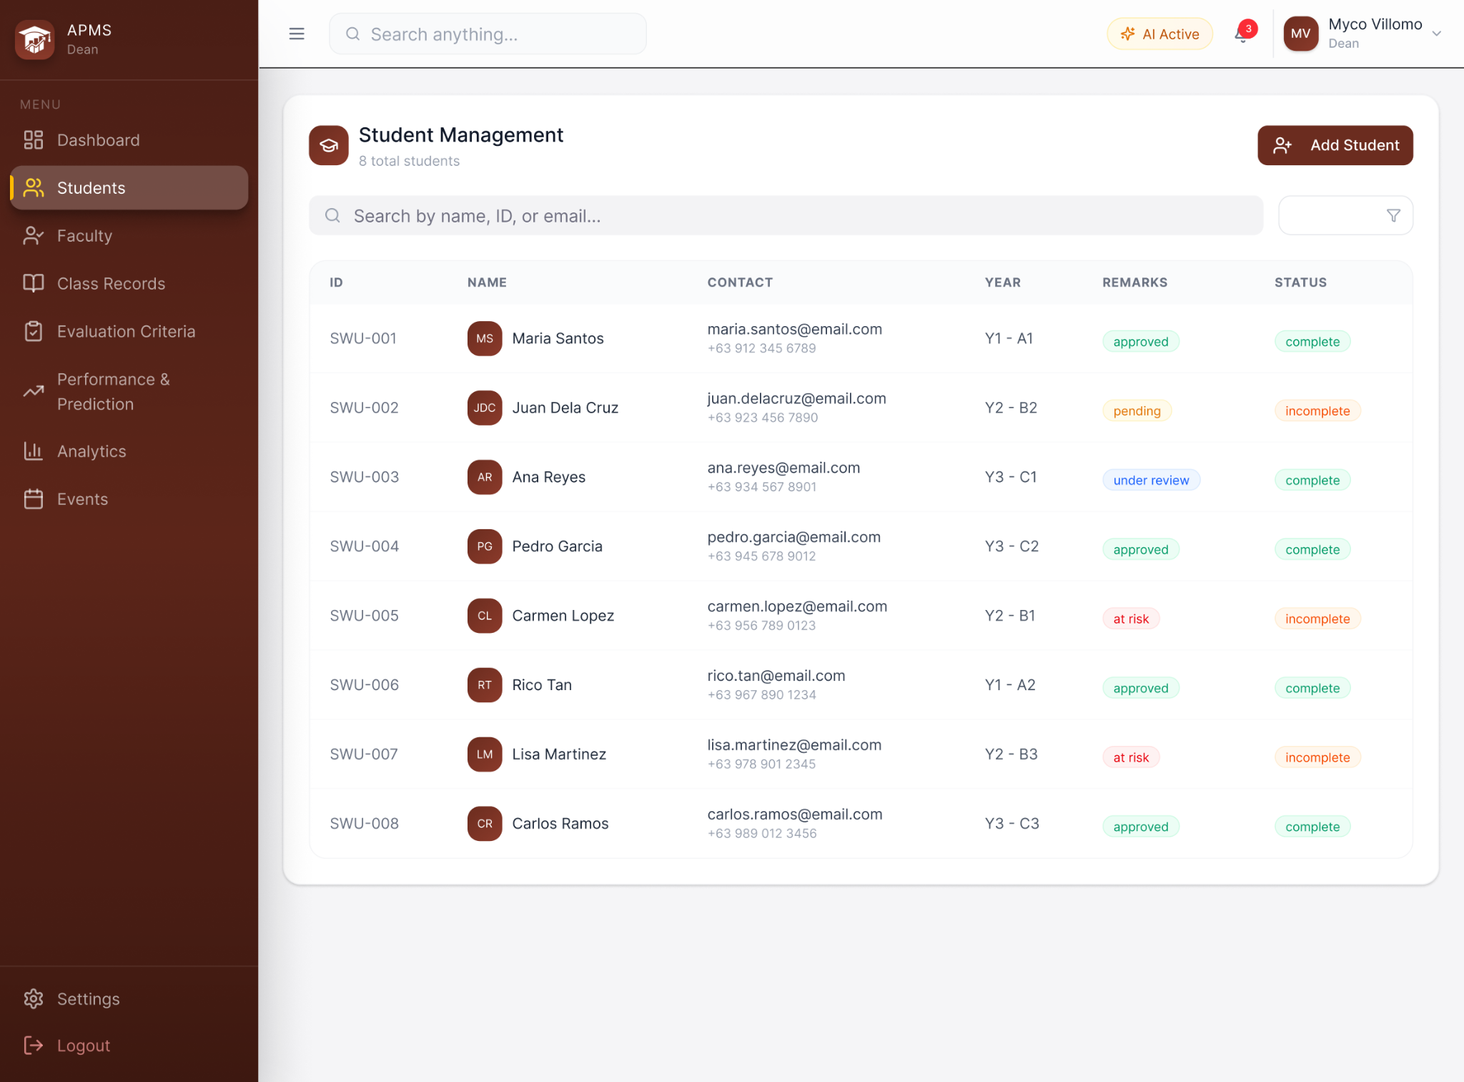
ACADEMIC ADMIN - STUDENT MONITORING PAGE
The figure above illustrates the Academic Admin Student Monitoring page. It provides authorized academic administrators with a searchable view of students and linked class records for monitoring and follow-up. Administrators may inspect student-level summaries, current standing, attendance indicators, performance trends, and at-risk classifications within their permitted organizational scope. Local roster information may be corrected where authorized, but assessment-score entry and day-to-day class record management remain Faculty responsibilities, and the page does not replace student information maintained in SWU SIS.
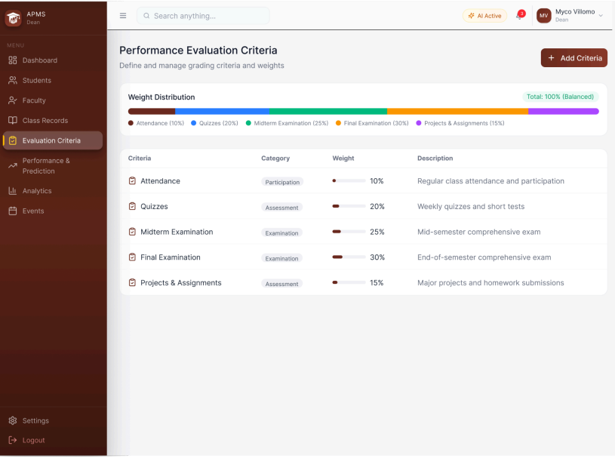
ACADEMIC ADMIN - PERFORMANCE EVALUATION CRITERIA PAGE
The figure above illustrates the Performance Evaluation Criteria page. This page allows Academic Admin users to define or maintain approved evaluation templates and grading structures that can be applied by faculty to class records. Criteria may include grading periods, component groups, assessment categories, and weight distributions. Faculty may apply the appropriate template and enter course-specific assessment items while the system verifies calculation rules such as total weight consistency. These criteria support monitoring calculations and AI input preparation but do not override institutional grading policy.

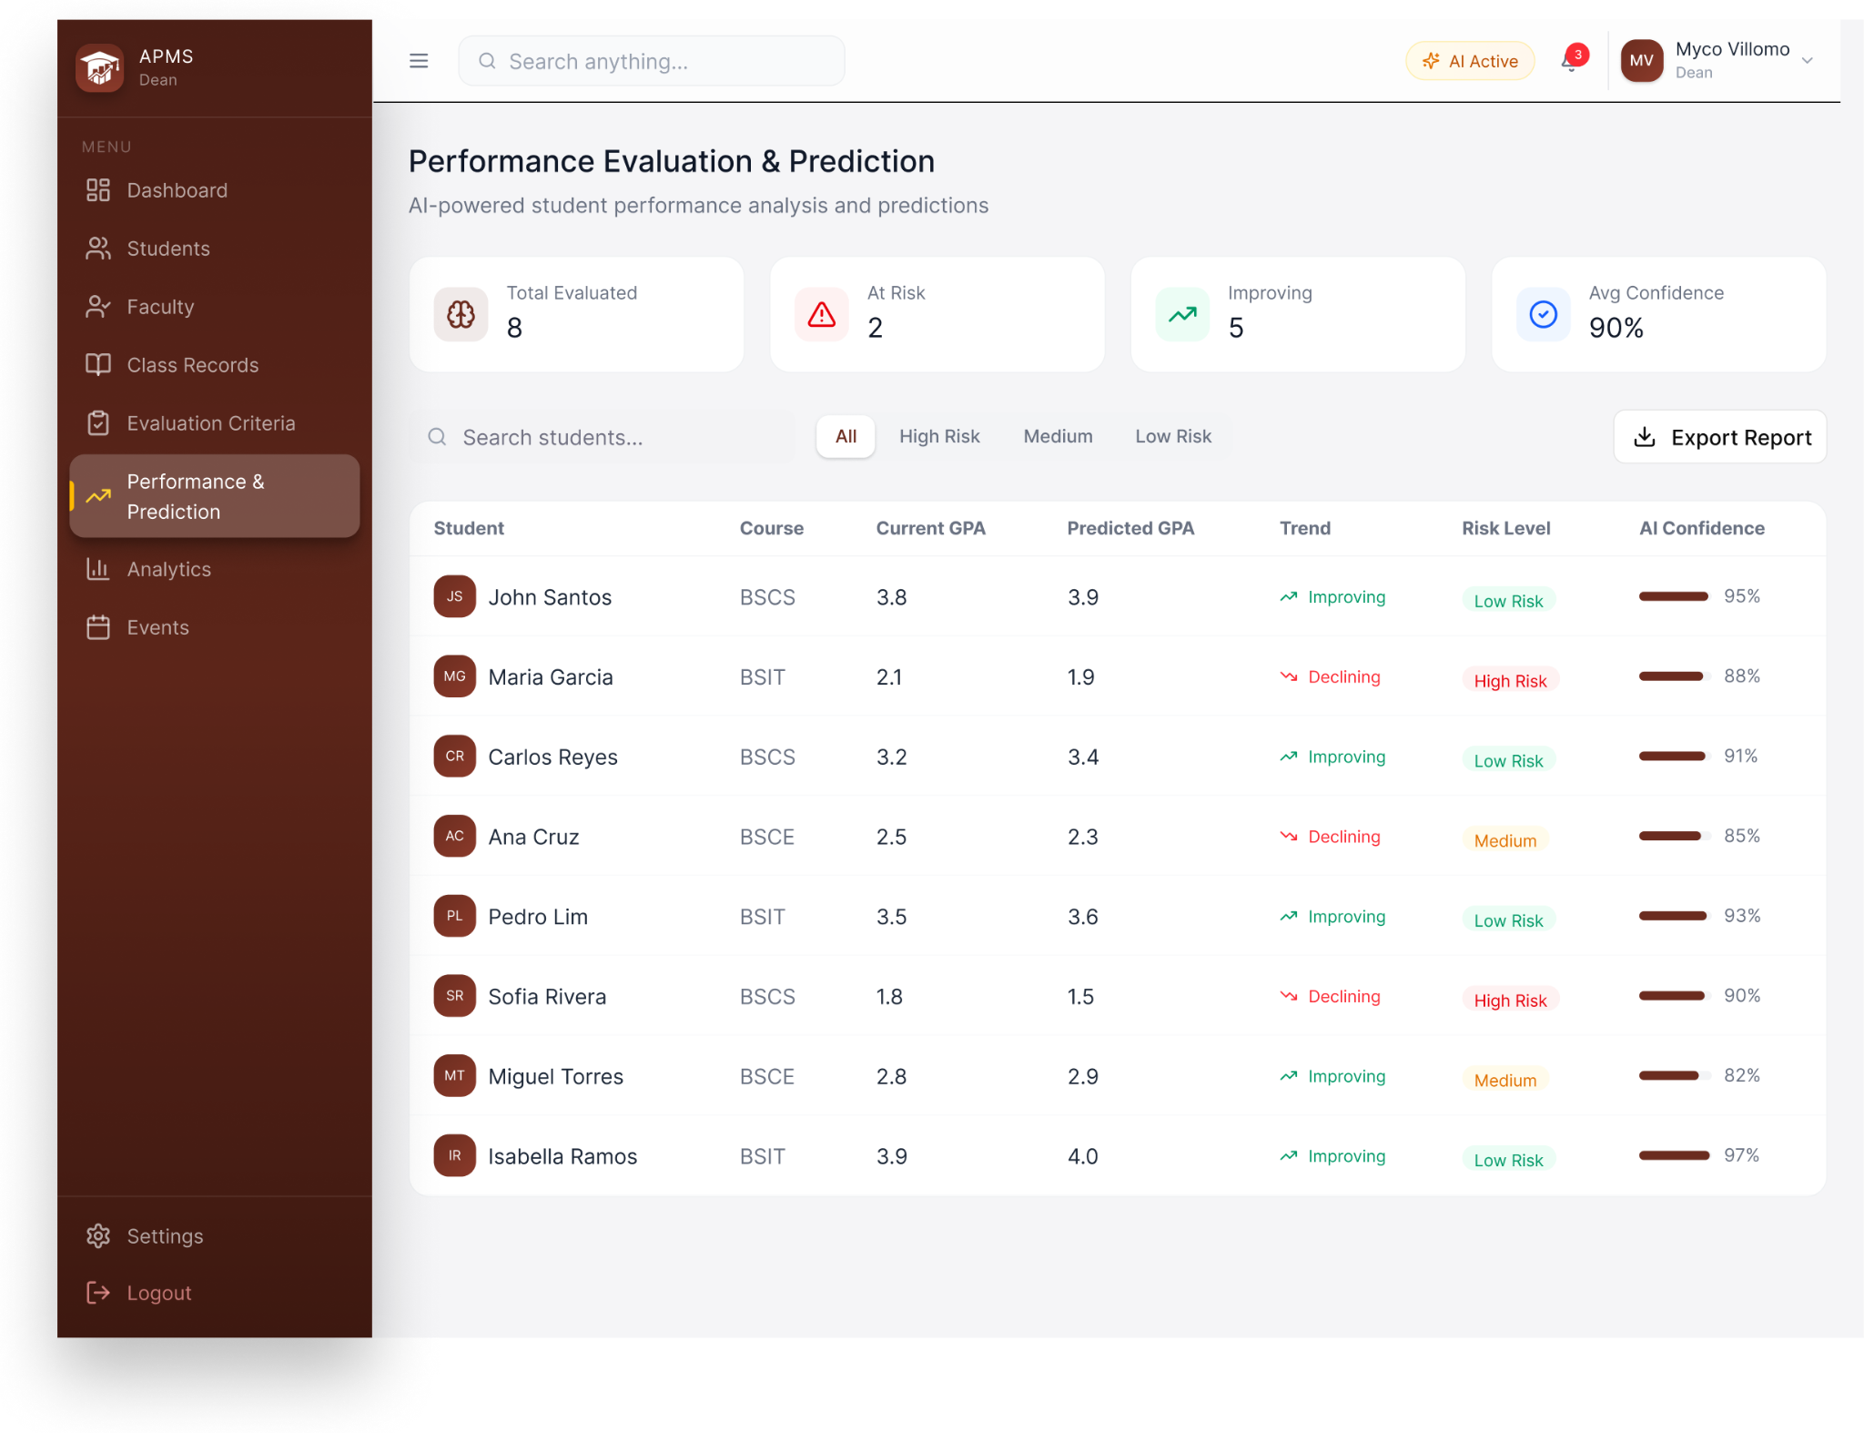
ACADEMIC ADMIN - PERFORMANCE EVALUATION AND PREDICTION PAGE
The figure above illustrates the Performance Evaluation & Prediction page, which contains the principal AI-assisted functionality of the system. It presents each student’s calculated current standing, predicted performance or outcome, performance trend, and at-risk classification so that faculty and authorized academic administrators can prioritize review. Where the selected model and validation method support a meaningful probability or confidence measure, that value may also be displayed; otherwise it is omitted rather than treated as an arbitrary score. The page may also show the most influential academic indicators contributing to the prediction. All AI outputs are advisory, require faculty interpretation, and are not official grades or automatic academic decisions.

REFERENCES
Ab Rahman, N. F., Wang, S. L., Ng, T. F., & Ghoneim, A. S. (2024). Artificial intelligence in education: A systematic review of machine learning for predicting student performance. ARASET: Journal of Artificial Intelligence Research and Applications in Science and Engineering Technology, 54(1), 198–221. doi:10.37934/ARASET.54.1.198221.
Albreiki, B., Zaki, N., & Alashwal, H. (2021). A systematic literature review of student performance prediction using machine learning techniques. Education Sciences, 11(9), 552. doi:10.3390/educsci11090552.
Alshabandar, R., Hussain, A. J., Liatsis, P., & Keight, R. (2022). Student performance prediction using machine learning techniques. 2022 International Conference on Intelligent Systems and Computer Vision (ISCV). IEEE. doi:10.1109/ACCESS.2022.3188767.
Bhangu, S., Provost, F., & Caduff, C. (2023). Introduction to qualitative research methods - Part I. Perspectives in clinical research, 14(1), 39–42. doi:10.4103/picr.picr_253_22
Brailas, A., Tragou, E., & Papachristopoulos, K. (2023). Introduction to qualitative data analysis and coding with QualCoder. American Journal of Qualitative Research, 7(3), 19-31. doi:10.29333/ajqr/13230.
Canalita, E., & Jugar, R. (2025). Development and evaluation of a collaborative lesson planning model for science teacher internships. International Journal of Learning, Teaching and Educational Research, 24(6), 588–608. doi:10.26803/ijlter.24.6.27.
Cobern, W., & Adams, B. (2020). When interviewing: how many is enough? International Journal of Assessment Tools in Education, 7(1), 73-79. doi:10.21449/ijate.693217.
Croucher, J. S. (2004). An upper bound on the value of the standard deviation. Teaching Statistics, 26(2), 54–55. doi:10.1111/j.1467-9639.2004.00157.x.
Demartini, C. G., Sciascia, L., Bosso, A., & Manuri, F. (2024). Artificial intelligence bringing improvements to adaptive learning in education: A case study. Sustainability, 16(3), 1347. doi:10.3390/su16031347.
Du, X., Yang, J., Hung, J. L., & Shelton, B. (2020). Educational data mining: A systematic review of research and emerging trends. Information Discovery and Delivery, 48(4), 225–236. doi:10.1108/IDD-09-2019-0070.
Etikan, I., Musa, S. A., & Alkassim, R. S. (2015). Comparison of Convenience Sampling and Purposive Sampling. American Journal of Theoretical and Applied Statistics, 5(1), 1-4. doi:10.11648/j.ajtas.20160501.11.
Ifenthaler, D., & Yau, J. Y.-K. (2020). Utilising learning analytics to support study success in higher education: A systematic review. Educational Technology Research and Development, 68, 1961–1990. doi:10.1007/s11423-020-09788-z.
International Association of Universities. (2026). About - WHED - IAU’s world higher education database. World Higher Education Database. https://www.whed.net/About.html.
Merino-Campos, C. (2025). The impact of artificial intelligence on personalized learning in higher education: A systematic review. Trends in Higher Education, 4(2), 17. doi:10.3390/higheredu4020017.
Mornie, M. N., Jali, N., Shiang, C. W., Mit, E., Saee, S., Jali, S. K., & Greer, D. (2026). Visualisation of user stories to UML use case diagram. Journal of Advanced Research in Applied Sciences and Engineering Technology, 63(3), 68-80. doi:10.37934/araset.63.3.6880.
Nahar, K., Shova, B. I., Ria, T., Rashid, H. B., & Islam, A. H. M. S. (2021). Mining educational data to predict students performance: A comparative study of data mining techniques. Education and Information Technologies, 26, 6051–6067. doi:10.1007/s10639-021-10575-3.
Namoun, A., & Alshanqiti, A. (2021). Predicting student performance using data mining and learning analytics techniques: A systematic literature review. Applied Sciences, 11(1), 237. doi:10.3390/app11010237.
Manu, E., & Akotia, J. (Eds.). (2021). Secondary research methods in the built environment. pp. 1-15. Routledge. doi:10.1201/9781003000532.
Napolitano, E. V., Masciari, E., & Ordonez, C. (2024). Integrating flow and structure in diagrams for data science. 2024 IEEE International Conference on Big Data. 5769-5774. doi:10.1109/BigData62323.2024.10826098.
Nurkholis, N., Wilarso, Sukamto, P., Anas, S. M., Jamaludin, S., & Umar, T. A. (2024). Digital survey for customer satisfaction of regional drinking water companies (PDAM) using the mWater application and the Slovin formula method. BIO Web Conf., 144(03006). doi:10.1051/bioconf/202414403006.
Rahman, M. M. (2023). Sample size determination for survey research and non-probability sampling techniques: A review and set of recommendations. Journal of Entrepreneurship, Business and Economics, 11(1), 42-62.
Salisi, G., & Balahadia, F. (2025). EduComply: a progress tracking system for compliance in teaching-learning deliverables using decision support system. International Journal of Science, Technology, Engineering & Mathematics, 5(3), 40–78. doi:10.53378/ijstem.353240.
Slater, P., & Hasson, F. (2025). Quantitative research designs, hierarchy of evidence and validity. Journal of psychiatric and mental health nursing, 32(3), 656–660. doi:10.1111/jpm.13135
Tetteh, S. G. (2024). Empirical study of Agile software development methodologies: a comparative analysis. Asian Journal of Research in Computer Science, 17(5), 30–42. doi:10.9734/ajrcos/2024/v17i5436.
Wu, C. (2022). Statistical inference with non-probability survey samples. Survey Methodology, 48(2), 283-311. Retrieved from https://www.math.uwaterloo.ca/~cb
wu/paper/22-Wu-SMJ.pdf.
Yuskovych-Zhukovska, V., Poplavska, T., Diachenko, O., Mishenina, T., Topolnyk, Y., & Gurevych, R. (2022). Application of artificial intelligence in education: Problems and opportunities for sustainable development. BRAIN: Broad Research in Artificial Intelligence and Neuroscience, 13(1Sup1), 339–356. doi:10.18662/brain.
Zhang, L. (2019). On valid descriptive inference from non-probability sample. Statistical Theory and Related Fields, 3(2), 103–113. doi:10.1080/24754269.2019.1666241.

